INDEX

[5 MAY 2022 – EDITORIALS 3](#_Toc102723608)

[EDIT 1: TUT CAPTURED WIL QUALIFICATION PRINTOUT FOR APPROVAL 3](#_Toc102723609)

[NOTE 1](../../../C:/Users/kris.KRISMOODLEYLAP/Dropbox1/Dropbox/OLUMS/Manuals/EDITORIAL%20OLUMS%20WIL/28%20APRIL%202022%20-%20WIL%20EDITORIALS.docx" \l "_Toc102723610) 3

[1 COVER PAGE – 6 May 2022 4](#_Toc102723611)

[4](#_Toc102723612)

[2 CONTENT PAGE 2 – 6 May 2022 5](#_Toc102723613)

[Page 1 – 6 May 2022 – BELOW THE LAYOUT FOR DETAILED LAYOUT 7](#_Toc102723614)

[PAGE 1 LAYOUT 8](#_Toc102723615)

[EDIT 2: WIL DOCUMENT FOR APPROVAL 9](#_Toc102723616)

[EDIT 3 – WIL QUALIFICATION DOCUMENT 12](#_Toc102723617)

[EDIT 4 – PAGE 1 - WIL QUALIFICATION DOCUMENT 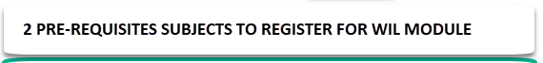 13](#_Toc102723618)

[EDIT 5 – PAGE 2 - REMOVE 14](#_Toc102723619)

[EDIT 6 – PAGE 3 – REMOVE PAGE 15](#_Toc102723620)

[EDIT 6 – CORE OUTCOMES LAYOUT REPLACED BY NOTE 3 16](#_Toc102723621)

[Note 3 CORE OUTCOME LAYOUT 17](#_Toc102723622)

[EDIT 7 – ELECTIVE OUTCOMES LAYOUT 18](#_Toc102723623)

[EDIT 8: ASSESSMENT RUBRIC FORMAT 19](#_Toc102723624)

[3 MAY 2022 20](#_Toc102723625)

[EDIT 1: WEBSITE DISCLAIMER 20](#_Toc102723626)

[EDIT 2 STATUS MENU EDITORIAL – ONLINE REGISTRATION 21](#_Toc102723627)

[2 MAY 2022 – STUDENT SUBMISSION OF REPORT 22](#_Toc102723628)

[1 REMOVE SPECIFIC IN BOTH MENUS 22](#_Toc102723629)

[EDIT 2 23](#_Toc102723630)

[EDIT 3 24](#_Toc102723631)

[EDIT 4 24](#_Toc102723632)

[Note 1 ADD COMMENT ON PAGE 25](#_Toc102723633)

[EDIT 5 26](#_Toc102723634)

[EDIT 6 27](#_Toc102723635)

[EDIT 7 29](#_Toc102723636)

[EDIT 8 29](#_Toc102723637)

[PREVIOUS EDITORIALS 1 MAY 2022 31](#_Toc102723638)

[1 STUDENT ONLINE REGISTRATION – REMOVE STEPS 7 AND 8 – INDEMNITY AND UNDERTAKING 31](#_Toc102723639)

[2 ADD NEW STEP 7 – UNDERTAKING AND INDEMNITY 32](#_Toc102723640)

[3 STEP 9 – REGISTRATION – QUERIES 33](#_Toc102723641)

[4 WORKSTATION / DIVISION – MERGE STEPS 4 AND 6 34](#_Toc102723642)

[1 EMPLOYER NAME 34](#_Toc102723643)

[2 DIVISION /BRANCH NAME 34](#_Toc102723644)

[3 WORKSTATION PHYSICAL ADDRESS 34](#_Toc102723645)

[28 APRIL 2022 36](#_Toc102723646)

[EDIT 1 36](#_Toc102723647)

[EDIT 2 36](#_Toc102723648)

[PREVIOUS DISCUSSIONS - 6 APRIL 2022 – NEW EDITORIAL 38](#_Toc102723649)

[1 WIL STUDENT MENU - Student adds results 38](#_Toc102723650)

[2 EDITORIAL 39](#_Toc102723651)

[Add Help Menu in [ONLINE WIL REGISTRATION] TO BE DISPLAY ON TOP OF SCREEN 39](#_Toc102723652)

[STUDENT ONLINE REGISTRATION 39](#_Toc102723653)

[25 APRIL 2022 EDITORIAL -WIL MENUS 41](#_Toc102723654)

[EDITORIALS 23 APRIL 2022 42](#_Toc102723655)

[1 FAQ 42](#_Toc102723656)

[2 ADD CHATS MENU ON LEFT 42](#_Toc102723657)

[3 CHANGE 42](#_Toc102723658)

[(ATTENTION VINEET) 43](#_Toc102723659)

[3 Change TITLE to: ONSITE VISITATION SCHEDULER 43](#_Toc102723660)

[4 ADD NEW FIELDS After Employer Workstation 43](#_Toc102723661)

[4 ADD NEW FIELD AFTER [SCHEDULE VISITATION] called [ONSITE VISIT REPORT] 43](#_Toc102723662)

[5 **OLD MENUS – UPDATED ON 27 APRIL - CHECK AND CHANGE [VISITATION STATUS]** AS FOLLOWS: 43](#_Toc102723663)

[6 {NEW EDITS} 45](#_Toc102723664)

[7 DASHBOARD QUERIES AND EDITS 46](#_Toc102723665)

[8 ALL STUDENTS menu 46](#_Toc102723666)

[QUERIES 47](#_Toc102723667)

[OLD EDITORIALS 49](#_Toc102723668)

# 5 MAY 2022 – EDITORIALS

## EDIT 1: TUT CAPTURED WIL QUALIFICATION PRINTOUT FOR APPROVAL

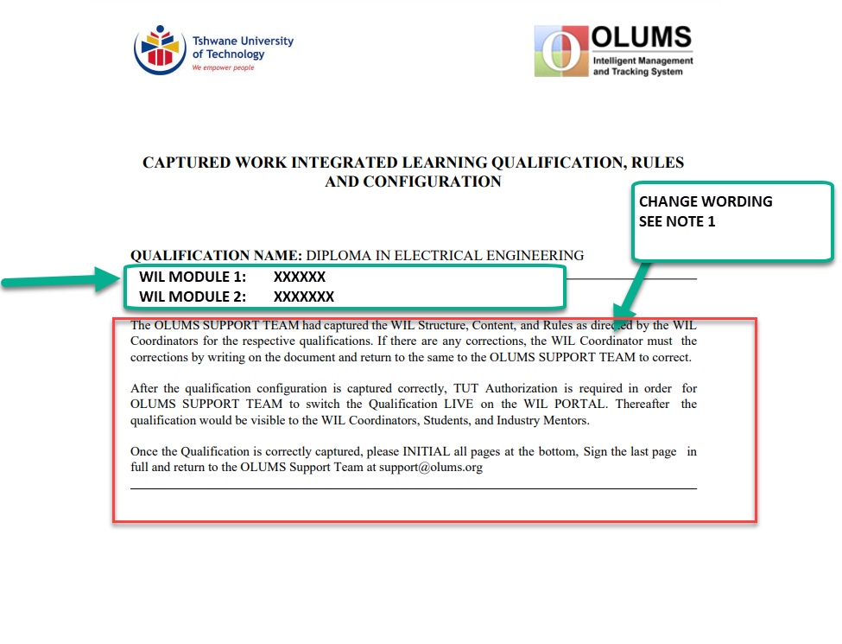

### NOTE 1

The OLUMS SUPPORT TEAM captured the WIL Structure, Content, and Rules as directed by the Work Integrated Learning Subject Matter Expert / Lecturer / Head of Department responsible for Work Integrated Learning Qualification within the respective Department. If there are any corrections or changes to the captured information, please forward these to the OLUMS SUPPORT TEAM.

After all changes and configurations are finalized, this Document must be Signed Off by the Head of Department and submitted to the OLUMS SUPPORT TEAM.

Upon receipt of the final Authorization, the OLUMS Team would switch the Approved WIL Module LIVE on the WIL PORTAL to make it visible to the WIL Coordinators, Students, and Industry Mentors.

It there are any queries, please contact

OLUMS Support Team

Tel: 087 826 1978 Email: support@olums.org

## COVER PAGE – 6 May 2022

NATIONAL DIPLOMA IN ELECTRICAL ENGINEERING

WORK INTEGRATED LEARNING

RULES AND OUTCOMES

WIL MODULE NAME : <WIL IN ELECTRICAL ENGINEERING

WIL MODULE NAME : <WIL IN ELECTRICAL ENGINEERING

WIL MODULE NAME : <WIL IN ELECTRICAL ENGINEERING

## CONTENT PAGE 2 – 6 May 2022

CONTENT

WIL MODULE1 : WIL IN ELECTICAL ENGINEERING

1 WIL MODULE RULES Page 1

2 OUTCOME : **<TITLE>** **CORE** Page 1

2 OUTCOME 2: **<TITLE>** **CORE** Page 1

3 OUTCOME 3: **<TITLE>** **CORE** Page 1

4 OUTCOME 4: **<TITLE>** **ELECTIVE GROUP 1** Page 1

5 OUTCOME 5: **<TITLE>** **ELECTIVE GROUP 1** Page 1

6 OUTCOME 6: **<TITLE>** **ELECTIVE GROUP 1** Page 1

7 OUTCOME 7: **<TITLE>** **ELECTIVE GROUP 1** Page 1

WIL MODULE2 : WIL IN COMPUTER ENGINEERING

1 WIL MODULE RULES Page 1

2 OUTCOME : **<TITLE>** **CORE** Page 1

2 OUTCOME 2: **<TITLE>** **CORE** Page 1

3 OUTCOME 3: **<TITLE>** **CORE** Page 1

4 OUTCOME 4: **<TITLE>** **ELECTIVE GROUP 1** Page 1

5 OUTCOME 5: **<TITLE>** **ELECTIVE GROUP 1** Page 1

6 OUTCOME 6: **<TITLE>** **ELECTIVE GROUP 1** Page 1

7 OUTCOME 7: **<TITLE>** **ELECTIVE GROUP 1** Page 1

## Page 1 – 6 May 2022 – BELOW THE LAYOUT FOR DETAILED LAYOUT

Page layout – see next page

## PAGE 1 LAYOUT

DIPLOMA IN ELECTRICAL ENGINEERING

WIL MODULE NAME: WIL IN ELECTRICAL ENGINEERING

WIL MODULE CODE: 2334445

**WIL MODULE RULES**

DURATION OF WIL MODULE 24 Weeks

WIL MODULE CODE: 2334445

DURATION OF WIL MODULE: 24 WEEKS

TOTAL CREDITS: 30

NUMBER OF ONSITE VISITATION: 1

**PRE-REQUISITE SUBJECTS**

SUBJECT 1 SUBJECT 1

SUBJECT 2 SUBJECT 1

SUBJECT 2 SUBJECT 1

SUBJECT 2

SUBJECT 3

SUBJECT 3

SUBJECT 3

SUBJECT 2

SUBJECT 3

SUBJECT 1

SUBJECT 2

SUBJECT 3

**WIL OUTCOMES**

OUTCOME : **<TITLE>** **CORE** **CREDITS**: 3

OUTCOME 2: **<TITLE>** **CORE** **CREDITS**: 3

OUTCOME 3: **<TITLE>** **CORE** **CREDITS**: 3

OUTCOME 4: **<TITLE>** **ELECTIVE GROUP 1** **CREDITS**: 3

OUTCOME 5: **<TITLE>** **ELECTIVE GROUP 1** **CREDITS**: 3

OUTCOME 6: **<TITLE>** **ELECTIVE GROUP 1** **CREDITS**: 3

OUTCOME 7: **<TITLE>** **ELECTIVE GROUP 1** **CREDITS**: 3

## EDIT 2: WIL DOCUMENT FOR APPROVAL

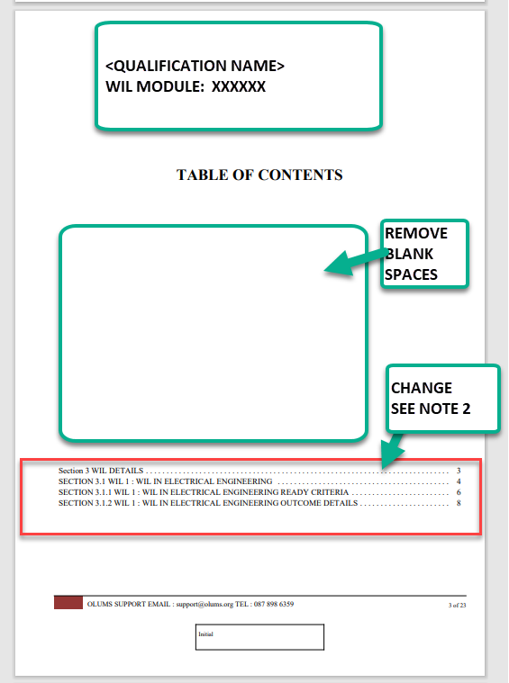

## EDIT 3 – WIL QUALIFICATION DOCUMENT

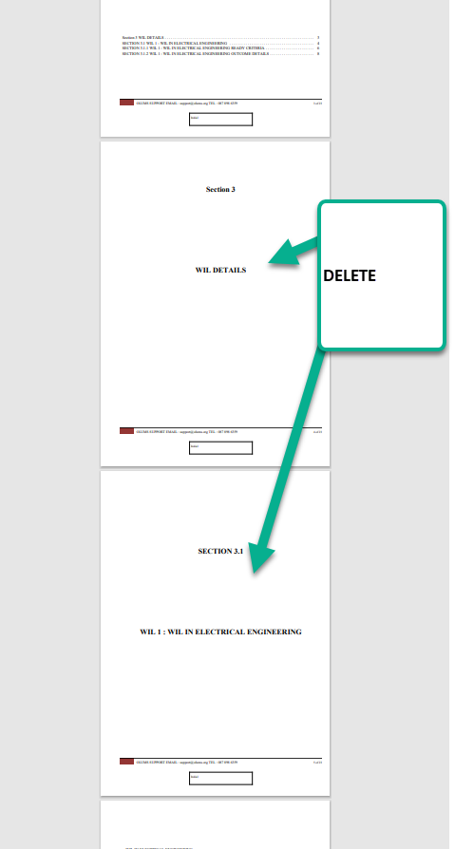

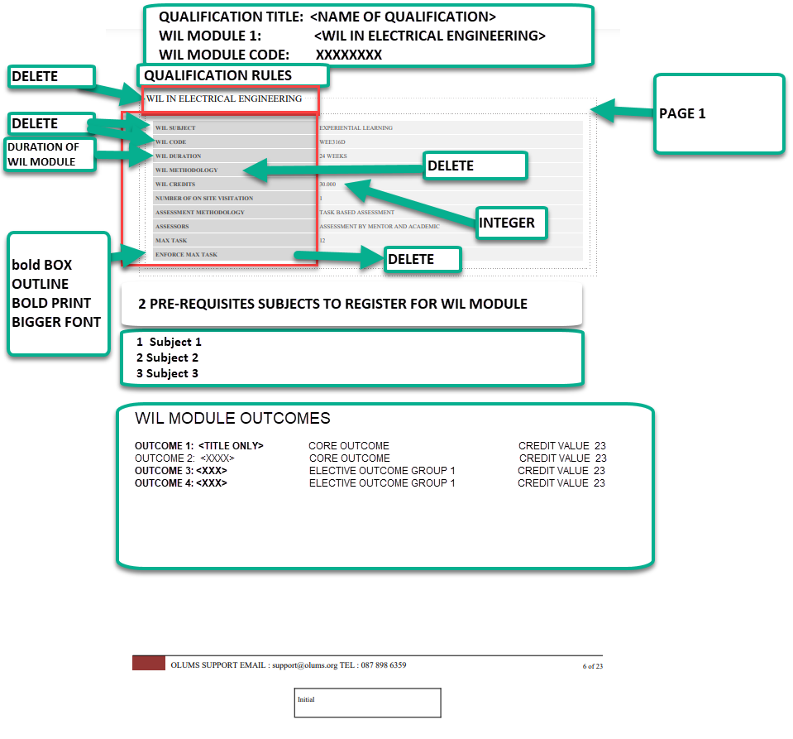

## EDIT 5 – PAGE 2 - REMOVE

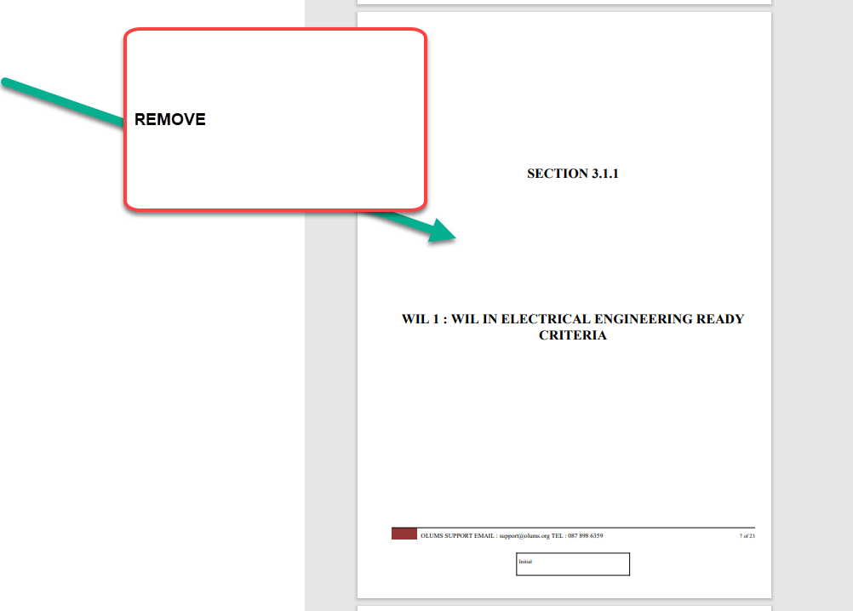

## EDIT 6 – PAGE 3 – REMOVE PAGE

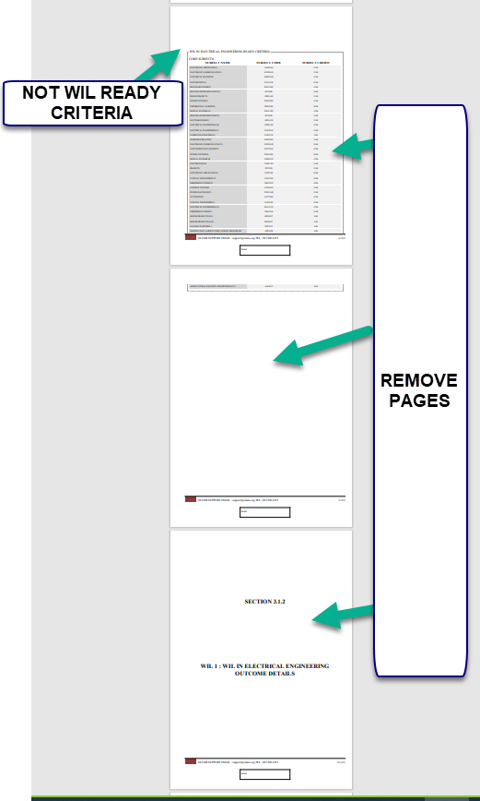

## EDIT 6 – CORE OUTCOMES LAYOUT REPLACED BY NOTE 3

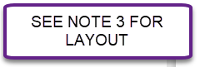

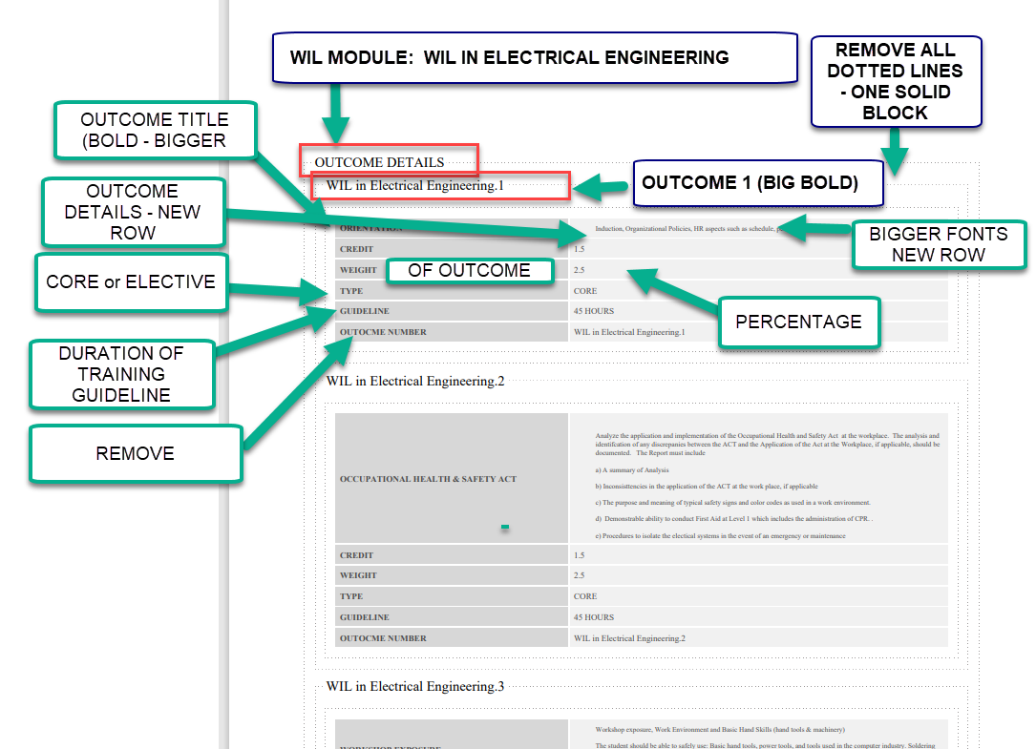

### Note 3 CORE OUTCOME LAYOUT

*WIL MODULE: WIL IN ELECTRICAL ENGINEERING*

OUTCOME 1: <TITLE> ORIENTATION>

DURATION OF TRAINING: 34 Hours

CORE OR ELECTIVE: CORE

CREDIT VALUE: 3

**OUTCOME 1 DETAIL**

**ASSESSMENT RUBRIC**

## EDIT 7 – ELECTIVE OUTCOMES LAYOUT

ELECTIVE OUTCOMES GROUP 1

**ELECTIVE GROUP RULES**

Choose any one of the following xxxxx

**Outcome 10:** <Titlexxxxxx>

**Outcome 11:** xxxxx

**OUTCOME 10 DETAIL**

XXXXXXXXXXXXXXXXXXXXXXXXXXXXXXXXXXXXXXXXXXXXXXXXXXXXXXXXXXXXXXXXXXXXXXXXXXXXXXXXXXXXXXXXXXXXXXXXXXXXXXXXXXXXXXX XXXXXXXXXXXXXXXXXXXXXXXXXXXXXXXXXXXXXXXXXXXXXXXXXXXXXXXXXXXXXXXXXXXXXXX

**ASSESSMENT RUBRIC**

|  |  |  |  |  |
| --- | --- | --- | --- | --- |
|  |  |  |  |  |
|  |  |  |  |  |
|  |  |  |  |  |
|  |  |  |  |  |
|  |  |  |  |  |
|  |  |  |  |  |
|  |  |  |  |  |
|  |  |  |  |  |

|  |  |  |
| --- | --- | --- |
| OUTCOME 10: ELECTIVE GROUP 1: <TITLE> | | |
|  | **CREDIT VALUE** | 34 |
|  | **TRAINING DURATION GUIDELINE** | 495 Hours |
|  | **GROUP RULE** | Repeated (Font 11) |
|  |  |  |

## EDIT 8: ASSESSMENT RUBRIC FORMAT

|  |  |  |  |  |
| --- | --- | --- | --- | --- |
| **ASSESSMENT RUBRIC** | | | | |
| **ASSESSMENT AREA** | | | **WEIGHT** | **ASSESSOR’S MARK**  **(0 to 100%)** |
| 1 | **COMPETENCY** | Rate the student’s level of competence in completing the Task | 30% |  |
| 2 | **LEARNING EXPERIENCE** | Rate the student’s learning experiences in completing the Task | 30% |  |
| 3 | **COGNITIVE LEVEL** | Rate the congitive level of complexity of the tasks that were completed | 15% |  |
| 4 | **SELF DIRECTED LEARNING** | Rate the student’s ability to complete the tasks without Supervision | 15% |  |
| 5 | **TIME MANAGEMENT** | Rate the student’s ability to manage tasks within the requisite time frame | 10% |  |
| TOTAL | | | 100% |  |

# 3 MAY 2022

## EDIT 1: WEBSITE DISCLAIMER

Protection of Personal Information Act

These conditions apply equally to all person/s who receive the Personal Information of Students and Graduates.

All Student and Graduate Personal Information, including CVs that the Durban University of Technology shares, is strictly confidential. All confidential Personal Information is specifically for the explicit attention of the person/s to whom the correspondence had been addressed and is intended for the sole purpose of the recruitment of Students and/or Graduates and the management of Work Integrated Learning students.

Student and Graduate confidential information can only be shared with the Employer’s Recruitment Personnel, who are directly involved with the respective Recruitment and the Management of Work Integrated Learning processes.

Under no circumstances whatsoever is any person/s allowed to share the Personal Information of Students and Graduates with any unauthorized person/s who are not directly involved with the Recruitment and Work Integrated Learning Management Processes for which the information had been shared by <Durban University>.

Save for the Employer’s Recruitment Personnel, Mentors and other persons related to the management of Work Integrated Learning Students, it is a criminal offence for any other unauthorized person to receive, and/or be in possession of, and/or to use, and/or to process any Personal Information of Students and Graduates that had been shared by the Durban University of Technology. All Personal Information that had been illegally obtained must be deleted/destroyed from all records immediately upon receipt.

All confidential Personal Information of unsuccessful Students and/or Graduates that had been shared with the Employer, including hard and soft copies of CVs, must be deleted/destroyed from all Computers and/or Storage devices and/or Filing Cabinets within seven (7) days after the respective Post/s for which the Candidates had been shared, had been filled.

# EDIT 2 STATUS MENU EDITORIAL – ONLINE REGISTRATION

Vineet please change

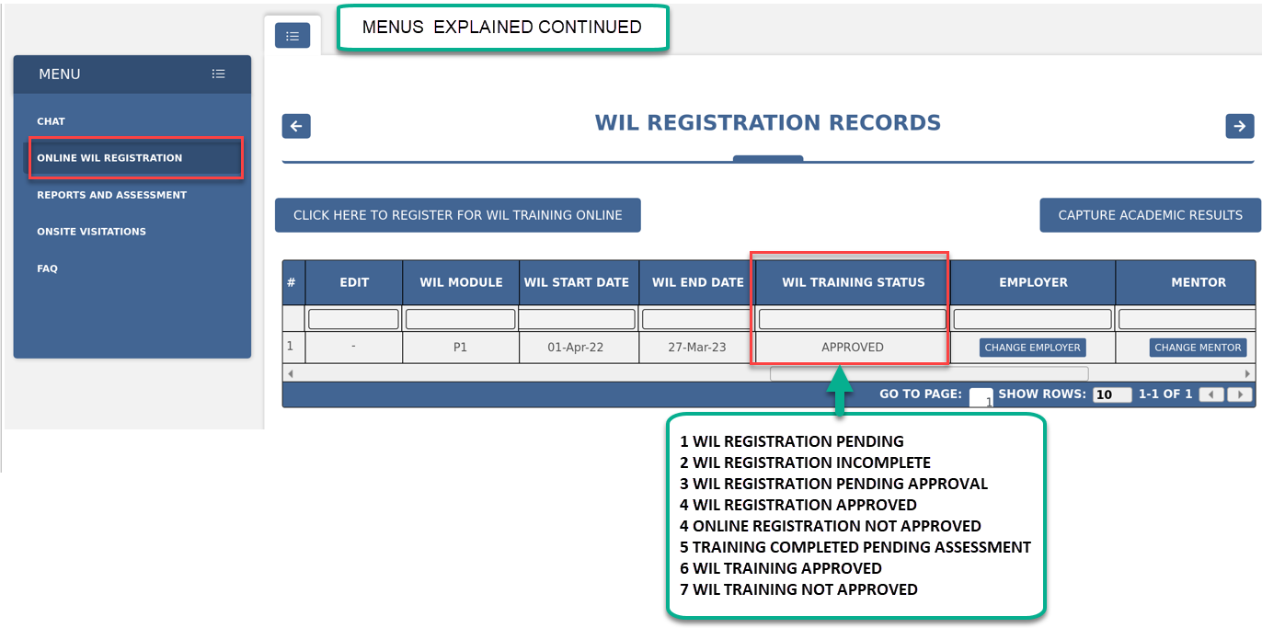

# 2 MAY 2022 – STUDENT SUBMISSION OF REPORT

## 1 REMOVE SPECIFIC IN BOTH MENUS

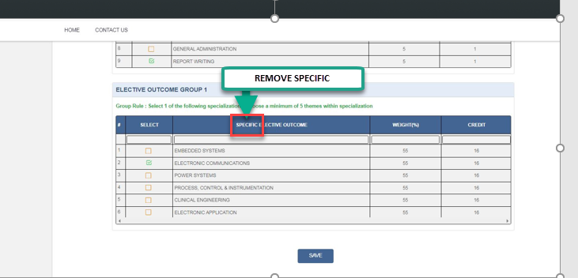

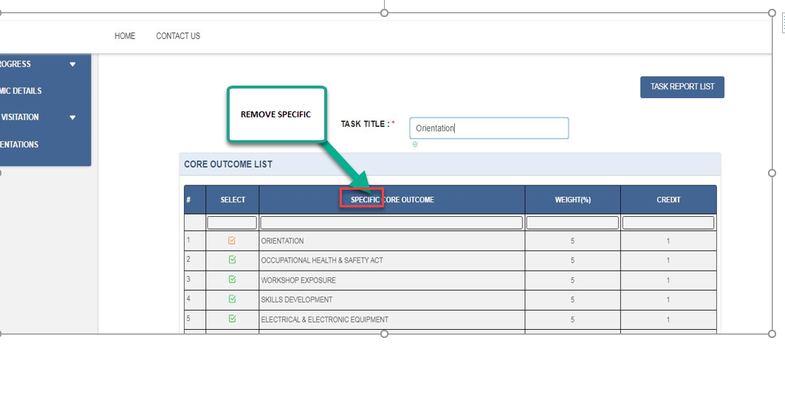

## EDIT 2

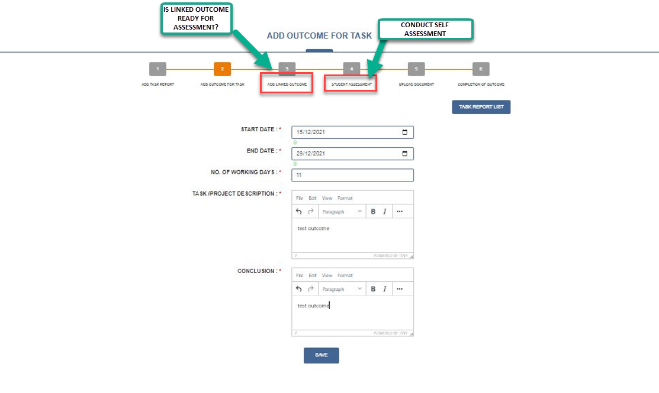

## EDIT 3

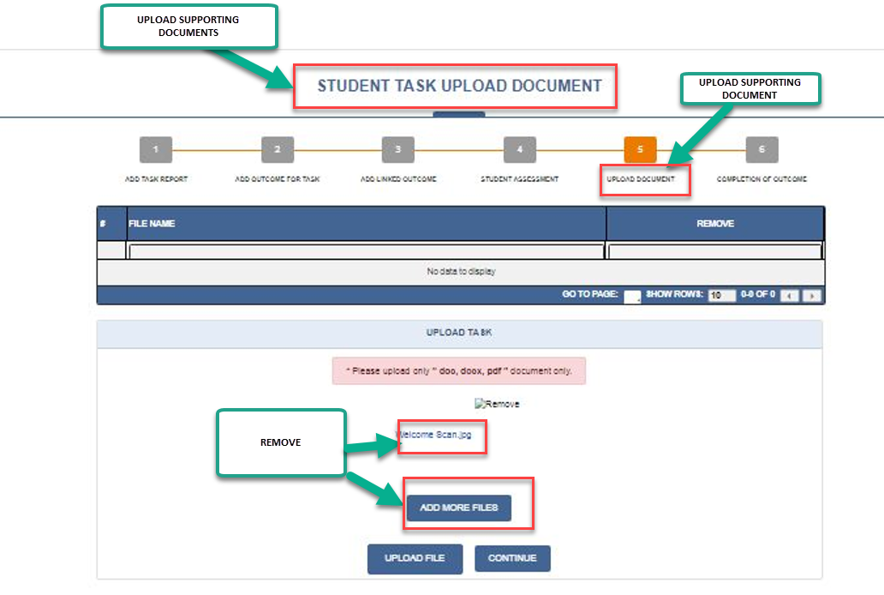

## EDIT 4

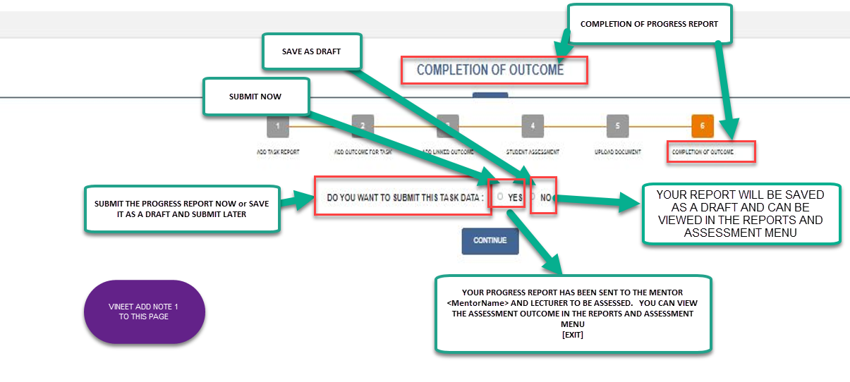

### Note 1 ADD COMMENT ON PAGE

1. PROGRESS REPORT SUBMISSION

The Student has the option to SUBMIT the Progress Report immediately or the SAVE the Report as a DRAFT.

If the Report is Submitted immediately, the Mentor would receive an email to Assess the Progress Report.

If the Mentor completes the Assessment of the Report, the Lecturer would be alerted to Assess the Report.

The Student can VIEW the Mentor’s and Lecturer’s Assessment in the [REPORTS AND ASSESSMENT] menu.

1. REPORT SAVED AS DRAFT

The Progress Report would be SAVED in the [REPORTS AND ASSESSMENT] menu as DRAFT REPORTS. The Student can Edit the Draft Progress Report and Submit it for Assessment

## EDIT 5

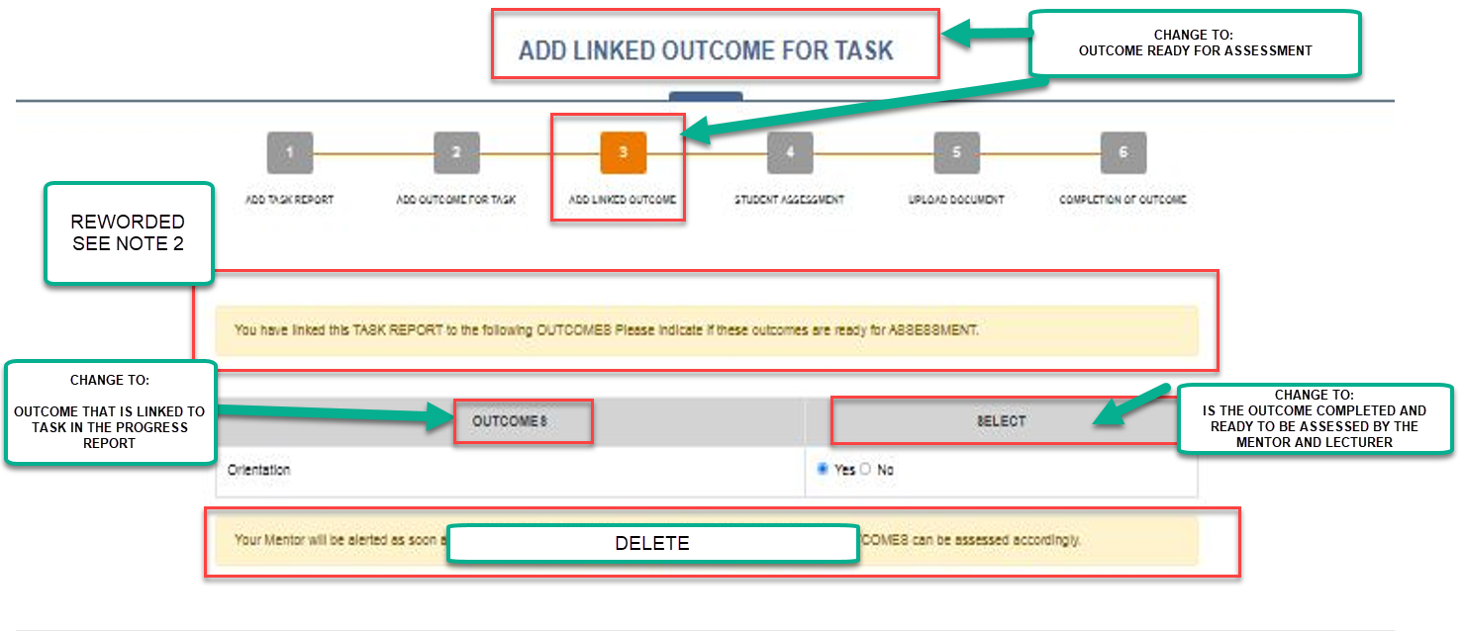**NOTE 2 TO BE ADDED TO PAGE**

PROGRESS REPORTS AND OUTCOME ASSESSMENTS

Progress Reports are LINKED to WIL OUTCOMES. Mentors and Lecturers need to be ALERTED by the Student when the linked Outcomes are completed and ready for assessment.

The Student must indicate whether the linked Outcomes are completed and ready to be assessed every time they submit a Progress Report.

Mentors and Lecturers would be alerted to APPROVE the Outcome that was marked as completed by the Student.

# Graphical user interface Description automatically generatedEDIT 6

NOTE 3 THE FOLLOWING TO BE ADDED THIS PAGE

*CREATING PROGRESS REPORTS*

STUDENTs must submit regular PROGRESS REPORTS in terms of the Qualification Rules. The Student would receive periodic reminders to submit their Progress Reports on time. Each Progress Report must be assigned a TASK NAME. The Report must include an Introduction, Body, and Conclusion.

**Start Date and End Date**

The start and end date refers to the Progress Report dates. The Tasks may be completed, or it may still be work-in-progress at the time of submitting the Progress Report

Task/Project Description

This section would include the Introduction and Body of the Report as described below.

Introduction

The introduction usually covers the description of what was done during the period of the Progress Report.

Body

The body deals with the processes and procedures of how that Student went about completing the tasks.

Conclusion

The conclusion should include reflective practice such as what has been learnt, whether the tasks could have been done more efficiently or more cost-effectively, any value-adding suggestions, etc.

Attachments

When a student submits their Progress Report, they would have the option to Attach one or more supporting documents to the Report

Link Task Report to WIL Outcomes

The Student would be required to link the Report to one of the relevant WIL Outcomes.

Self-Assessment

Before submitting a Report, the Student must assess their performance by completing the Self -Assessment Rubric

Student Report forwarded to Mentor for evaluation

After the Student Submits the Report, the Industry Mentor receives an email Alert to Assess the Student's Progress Report.

Student Report forwarded to Lecturer for Evaluation

After the Industry Mentor completes the Assessment, the WIL Coordinator (Lecturer) gets an email alert to Assess the Student's Report. The Student, Mentor, and WIL Coordinator can view the Assessments in real-time.

**TIP**

It is recommended that the Student first draft the Progress Report in MS Word, then check for Grammar and Spelling errors by using the online service at www.grammarly.com. After ensuring that the Report is error-free, the Student must Copy and Paste the Report onto the WIL Portal

# EDIT 7

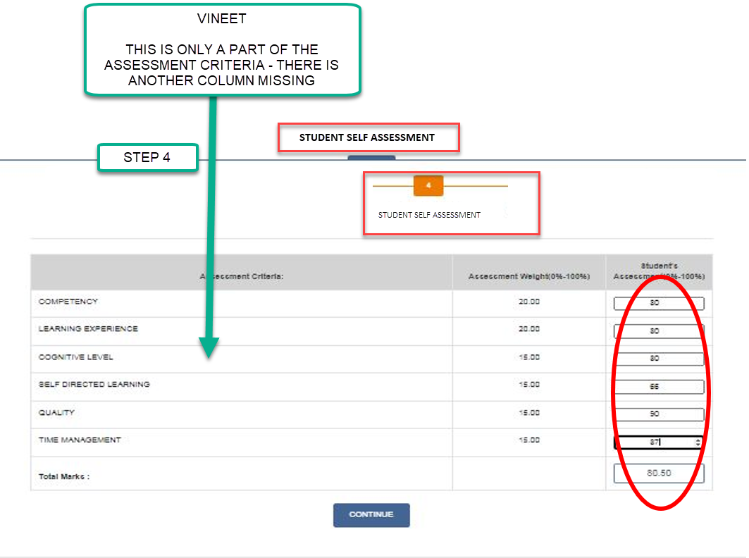

# EDIT 8

ADD NEW BUTTON next to the CREATE PROGRESS REPORT button.

**[VIEW STATUS OF PROGRESS REPORTS AND OUTCOMES]**

**This takes the Student to the page with the Draft Reports etc**

# PREVIOUS EDITORIALS 1 MAY 2022

## 1 STUDENT ONLINE REGISTRATION – REMOVE STEPS 7 AND 8 – INDEMNITY AND UNDERTAKING

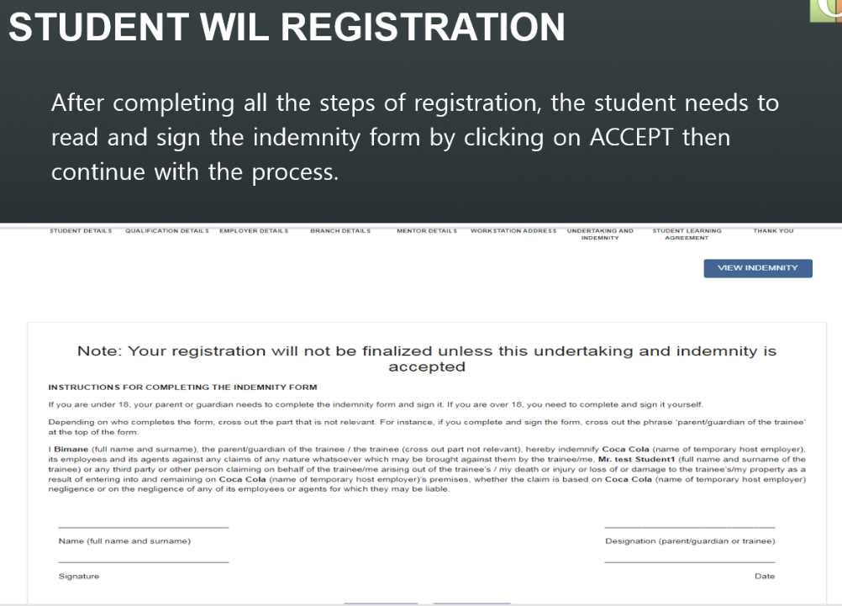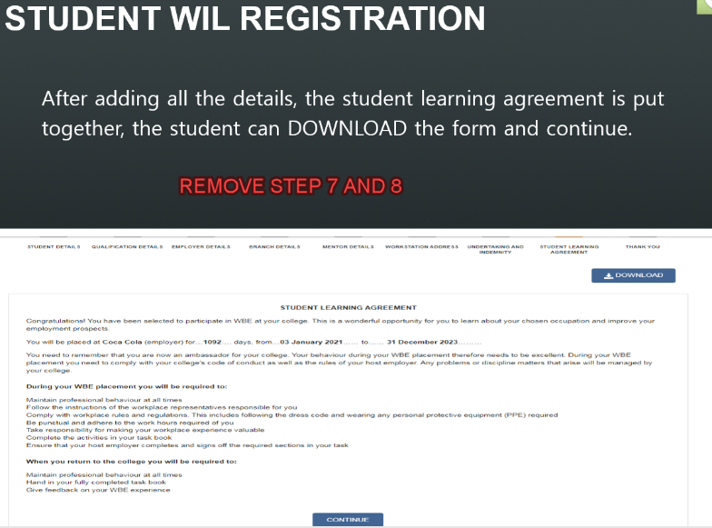

## 2 ADD NEW STEP 7 – UNDERTAKING AND INDEMNITY

INDEMMNITY AND UNDERTAKING

1. **<Tshwane University of Technology> POLICIES AND RULES**

I, **<fullname>** do hereby Agree to adhere to all <Tshwane University of Technology> Regulations, Policies, Student Rules, Work Integrated Policies during my Work Integrated Learning Training. I will familiarize myself with the Policies of the Institution which are on the <Tshwane University of Technology> Website

**2** **Protection of Personal Information Act**

I grant permission to <Tshwane University of Technology>, its Employees, and Administrators to share my Personal Information with any person/s, including Employers and Mentors involved in the administration, supervision, and management of my Work Integrated Learning training. The Administrators would take the necessary precautions to ensure that your personal information is protected as required by Law.

3 **EMPLOYER POLICIES**

I agree to comply with all the Workplace Rules and Regulations during my Training program.

**4 INDEMNITY**

I, or any third party, or other person claiming on behalf of me, hereby indemnified <Tshwane University of Technology> and the Host Employer, <Employer Name>, its employees, and its agents against any claims of any nature whatsoever which may arise from any loss or injury to myself or death as a result of an accident or negligence on the part of the Employer and its employees.

# 3 STEP 9 – REGISTRATION – QUERIES

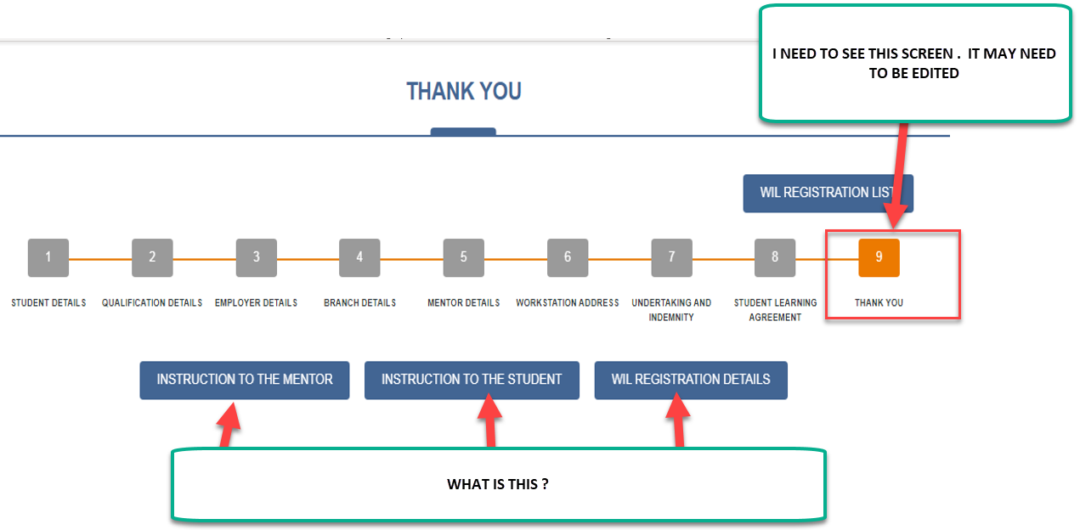

# 4 WORKSTATION / DIVISION – MERGE STEPS 4 AND 6

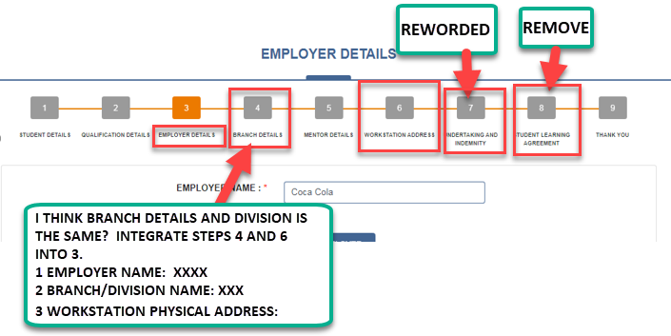

{VINEET - ADD THE FOLLOWING COMMENT TO THIS PAGE}

### EMPLOYER NAME

An Employer Name is the primary parent’s name of an organization such as Eskom, Telkom, MTN, Transnet, Vodacom, etc. An Employer may have numerous Branches or Divisions at various locations locally, nationally, and internationally that function as independent or separate Business Units.

### DIVISION /BRANCH NAME

A Division or Branch is a child of the parent company. The Division or Branch may be located at different physical locations and operate as independent Business Units. The Division or Branch would have a Name, or it could be known by its geographical location, such as XYZ Enterprises Gauteng, XYZ Enterprises Cape Town, etc. If an Employer is a microenterprise and does not have Divisions or Branches, enter Not Applicable for the Division or Branch Name

### WORKSTATION PHYSICAL ADDRESS

The Workstation is the physical location where the student would conduct their WIL Training. The Workstation Name would be the name of the Branch or Division of an Organization or Company. The Workstation is the physical location that the student would conduct their WIL Training. The Workstation Name would be the name of the Branch, or Division of an Organization or Company.

# 28 APRIL 2022

## EDIT 1

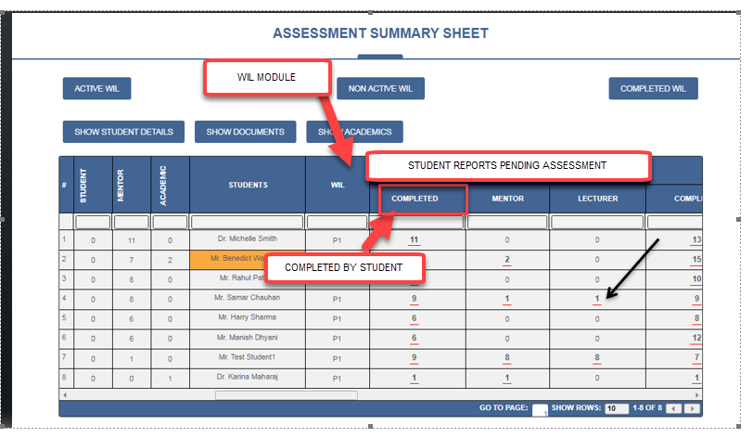

## EDIT 2

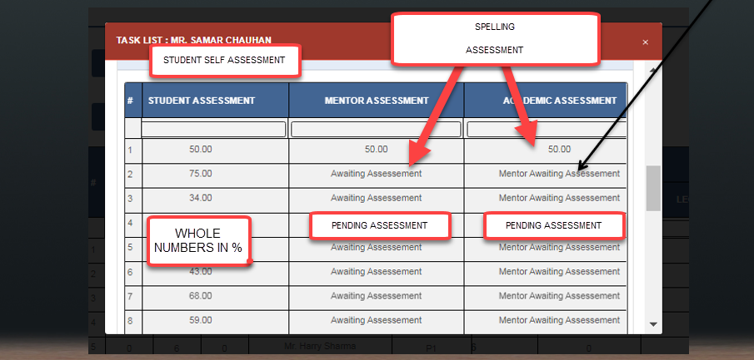

# PREVIOUS DISCUSSIONS - 6 APRIL 2022 – NEW EDITORIAL

### 1 WIL STUDENT MENU - Student adds results

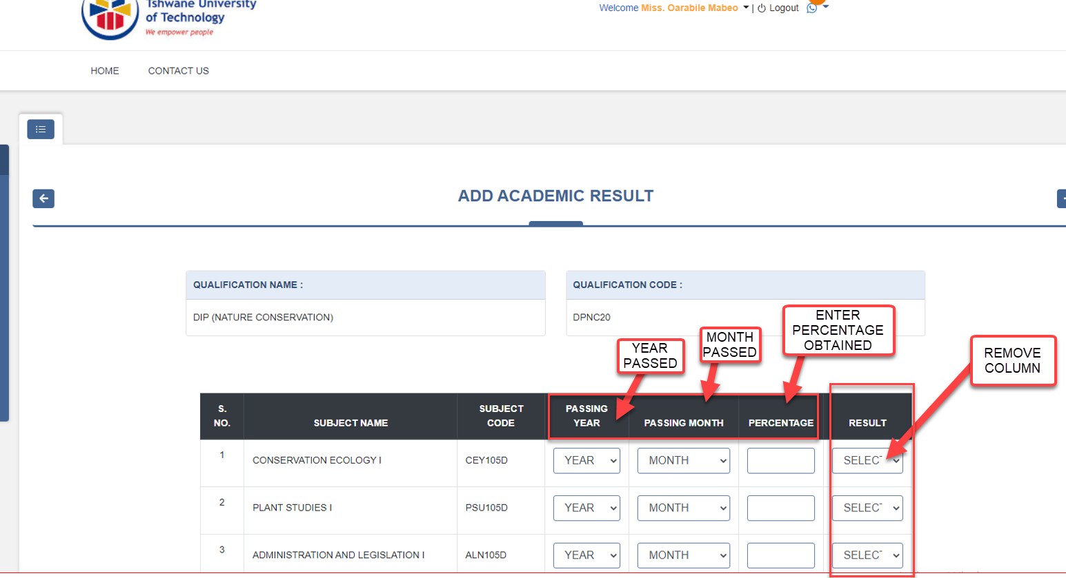

### 2 EDITORIAL

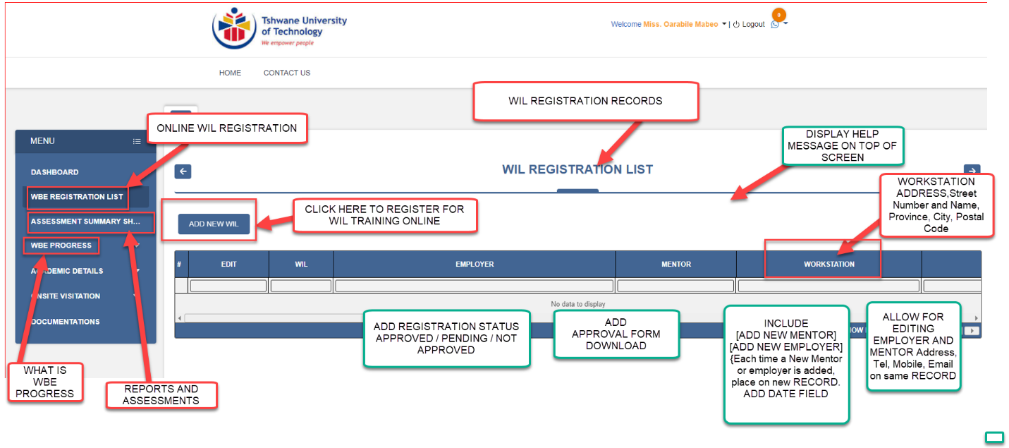

### Add Help Menu in [ONLINE WIL REGISTRATION] TO BE DISPLAY ON TOP OF SCREEN

### 

### STUDENT ONLINE REGISTRATION

Students are required to Register their WIL TRAINING on the WIL PORTAL within 7 Days of the start of their Training. Registration aims to ensure that the Lecturers AND Mentors can monitor, manage, and assess the Student WIL Training from the beginning of the Training. After the Student submits the Online WIL Registration, the WIL Coordinator (Lecturer) will receive an alert to APPROVE the Registration. The WIL Coordinator must check the Student's Academic credentials, Employer Name, Workstation Address where the Student would be based, Mentors Name, Email Address, and Telephone Number are correctly completed by the Student. The Workstation Address is the Physical Address where the Student would be stationed during their Training. The WIL Coordinator must also check the credentials of new Employers and Mentors before provisionally approving them.

## 25 APRIL 2022 EDITORIAL -WIL MENUS

1. QUERY

What is the Purpose of “CHANGE PLACEMENT STATUS” MENU?

Is it:

1. to Change to Status of WIL PLACEMENT from UNPLACED to PLACED OR,
2. to Change the PERMANENT PLACEMENT of the STUDENT

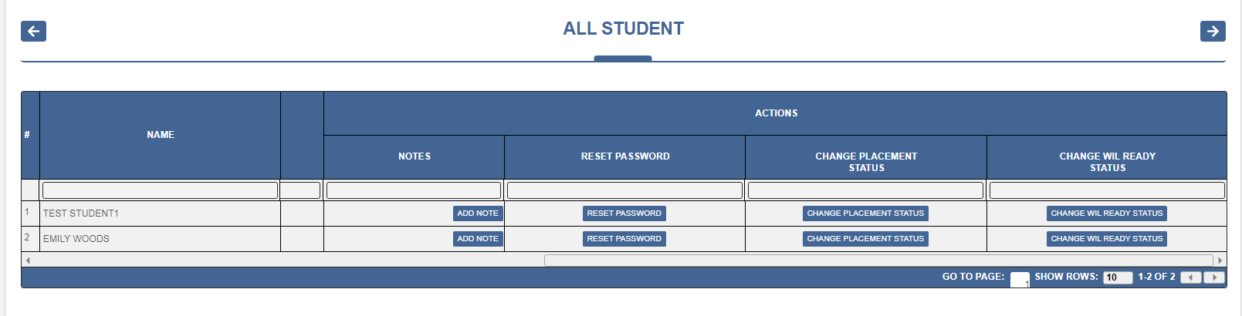

1. PLEASE MAKE THE BACK GROUND COLOUR RED OF ALL TASKS PENDING ASSESSMENT, ETC
2. ALSO CHANGE MENU TITLE AS SHOWN BELOW

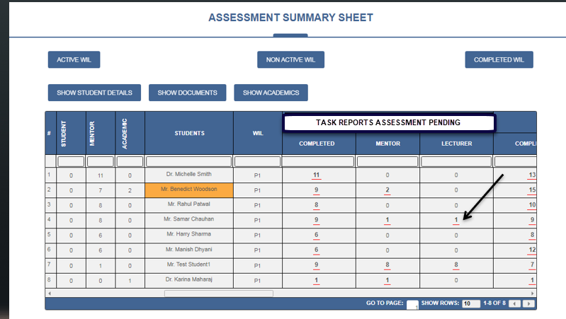

## EDITORIALS 23 APRIL 2022

### FAQ

* Must be in Home Menu on left Vineet > Got it, Will do this
* The FAQ Title must be Hyperlinked to the Details – do not place the Tutorial in the Main Menu. The Home Page of the FAQ should only contain Titles. Allow for addition of Sub-Title or Tutorial or Videos Vineet > It is working same

### ADD CHATS MENU ON LEFT

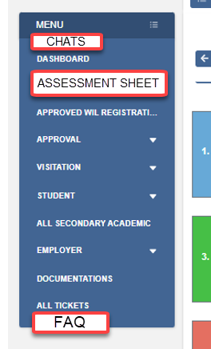

### 3 CHANGE

1. LANDING PAGE MENU FROM ASSESSMENT SUMMARY SHEET TO ASSESSMENT SHEET Vineet > Got it, Will do this
2. “wil pending approval” to “ STUDENT REGISTRATION PENDING APPROVAL”   
   Vineet > Got it, Will do this
3. Query- WHAT IS [VISITATION PENDING APPROVAL]? Is it STUDENT VISITATION OVERDUE? Is the Alert Linked to the List of Students whose VISIT is OVERDUE? Vineet > Visitation Pending Approval is Schedule Visitation, We will changes its title to schedule visitation, It shows the list of all student who are pending Visitation Schedule (we will add one column to show overdue)

### (ATTENTION VINEET)

ONSITE VISITATION SCHEDULER

Vineet

### Change TITLE to: ONSITE VISITATION SCHEDULER

### ADD NEW FIELDS After Employer Workstation

* 1. PROVINCE, CITY, SURBURB

### ADD NEW FIELD AFTER [SCHEDULE VISITATION] called [ONSITE VISIT REPORT]

* The Onsite Student REPORT and Mentor Visitation Report Rubric should be VIEWED here.
* The Mentor Assessment Report must only be completed once even if multiple students assigned to the same Mentor. All linked students will have same report
* ADD THE FOLLOWING BUTTONS

[DOWNLOAD / EMAIL STUDENT REPORT] {Default Email is the Students Email – can be Edited}

[DOWNLOAD/EMAIL MENTOR REPORT] {Default Email is Mentor – Edit}

REPEAT THESE REPORTS

### **OLD MENUS – UPDATED ON 27 APRIL - CHECK AND CHANGE [VISITATION STATUS]** AS FOLLOWS:

* 1. VISITATION STATUS
* (NOT YET VISITED),
* (VISIT PENDING); (tt 1)
* (OVERDUE); tt2
* (Visited on 23/03/21; 3/1/22);
* ( ONSITE VISIT REPORT PENDING) tt3

{Vineet please ensure that the Tooltips are Captured in the Menus. I noticed that lots of Menus did not include the Tooltips that a spent a long time on}

[VISIT PENDING] Status changes after a VISIT is scheduled to [VISIT PENDING] }

Tooltip1:

VISIT PENDING

An ONSITE VISIT has been scheduled. The Visit is PENDING.

{Note to Vineet –

1. This Status changes to [ONSITE VISIT REPORT PENDING] after the VISIT Date
2. If the Academic Re-schedules the Visit after the Visit Date without Capturing the Onsite Report, then Change the Status to [VISIT PENDING] }

Tooltip2:

OVERDUE

According to the Qualification Rules an Onsite Visit to monitor the Student’s Training is overdue

Tooltip3:

ONSITE VISIT REPORT PENDING

After a Scheduled Visit date had passed, the WIL Coordinator / Lecturer must complete the ONSITE VISITION STUDENT AND MENTOR ASSESSEMENT REPORT. This REPORT is PENDING.

(Trigger 1: When Academic completes the Onsite Visit Report, the STATUS changes to [VISITED on xxx]

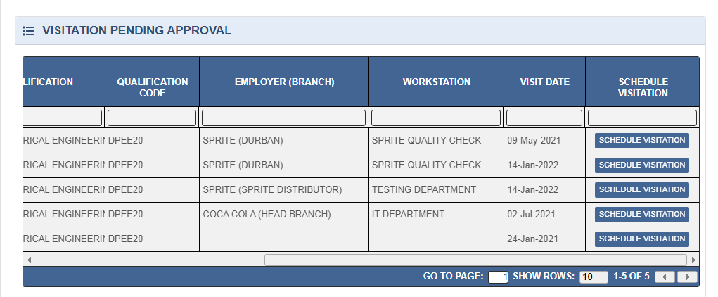

### {NEW EDITS}

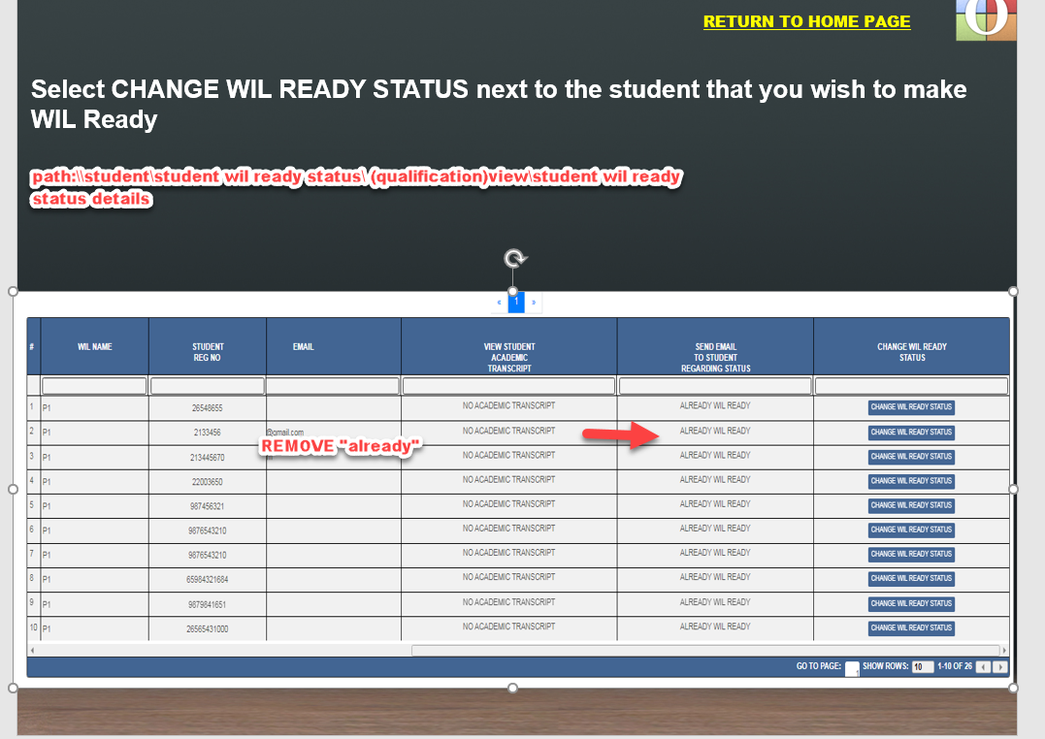

1. Query – What does Forwarded Tickets do ? Vineet > Its removed from dashboard

### DASHBOARD QUERIES AND EDITS

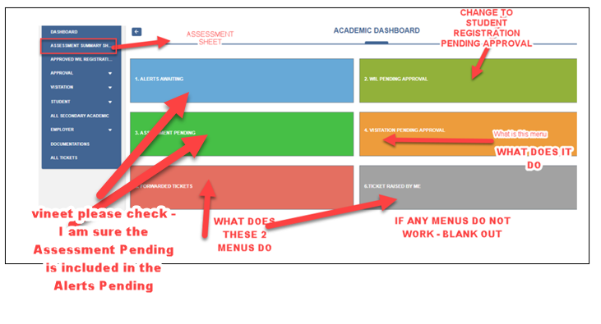

### ALL STUDENTS menu

All Students must include EVERY STUDENT within the WIL Qualification linked to the Academic. This Student Data comes from the ITS Table irrespective whether Students are Registered on the WIL Portal or Not

**ADD FIELDS**

1. REGISTERED ON WIL PORTAL (YES/NO)
2. STUDENT IS WIL READY: (YES/NO)

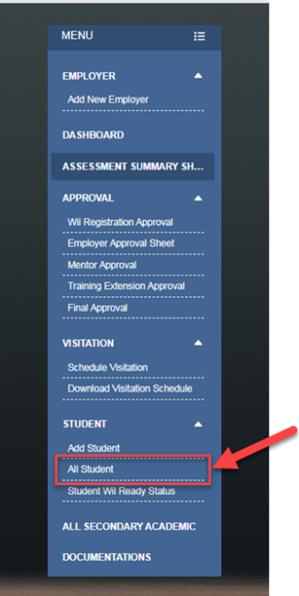

### QUERIES

1. SUPPORT TICKETS are routed to The Primary or Secondary Academic
   1. then Escalated to WIL ADMIN >escalated to OLUMS SUPPORT   
      Vineet > All tickets will be routed to WIL Admin, WIL admin will assign to Primary or Secondary. in case of mentor ticket, we will show dropdown with Student Name Reg Number and Primary Academic
2. SECRETARY MENUS – WHAT DOES IT LOOK LIKE  
   Vineet > Only Assessment Summary with Qualification dropdown of his/her Department + WIL Ready Status page (In Progress)
3. HOW IS THE SITE VISITATION ASSESSED – EMPLOYER ACCREDITATION, MENTOR APPROVAL, STUDENT ASSESSMENT RUBRICS
4. SITE VISITATION PRINTOUT DOWNLOADS. Where and how is this downloaded
5. HOW DOES THE ACCREDITATION OF EMPLOYER PROCESS WORK – RUBRIC
6. HOW ARE THE ACCREDITATION CERTIFICATES PRINTED
7. Where is the CHAT MENU?  
   Vineet > On the right hand top of the page, whatsapp icon
8. WHAT IS IN THE DOCUMENTS MENU

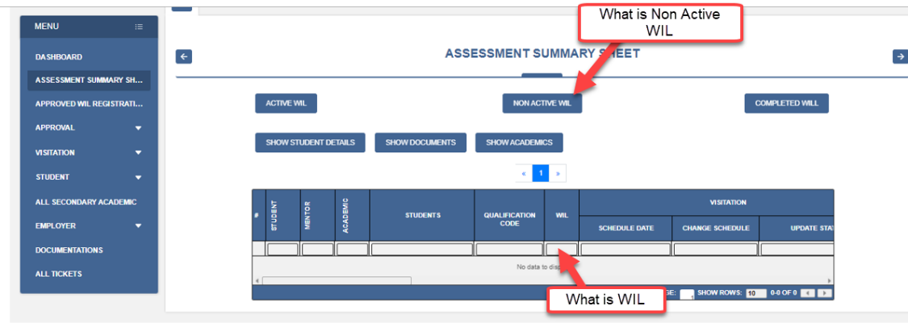

## OLD EDITORIALS

ADD: APPROVED, PRINT NAME, POSITION

APPROVAL OF WIL QUALIFICATION

I confirm that the detail of the Qualification is captured correctly on the OLUMS SYSTEM

**SIGNATURE:** \_\_\_\_\_\_\_\_\_\_\_\_\_\_\_\_\_\_\_\_\_\_\_\_\_

**NAME:**  \_\_\_\_\_\_\_\_\_\_\_\_\_\_\_\_\_\_\_\_\_\_\_\_\_

**DESIGNATION:**  \_\_\_\_\_\_\_\_\_\_\_\_\_\_\_\_\_\_\_\_\_\_\_\_\_\_

**DATE:**  \_\_\_\_\_\_\_\_\_\_\_\_\_\_\_\_\_\_\_\_\_\_\_\_\_\_\_

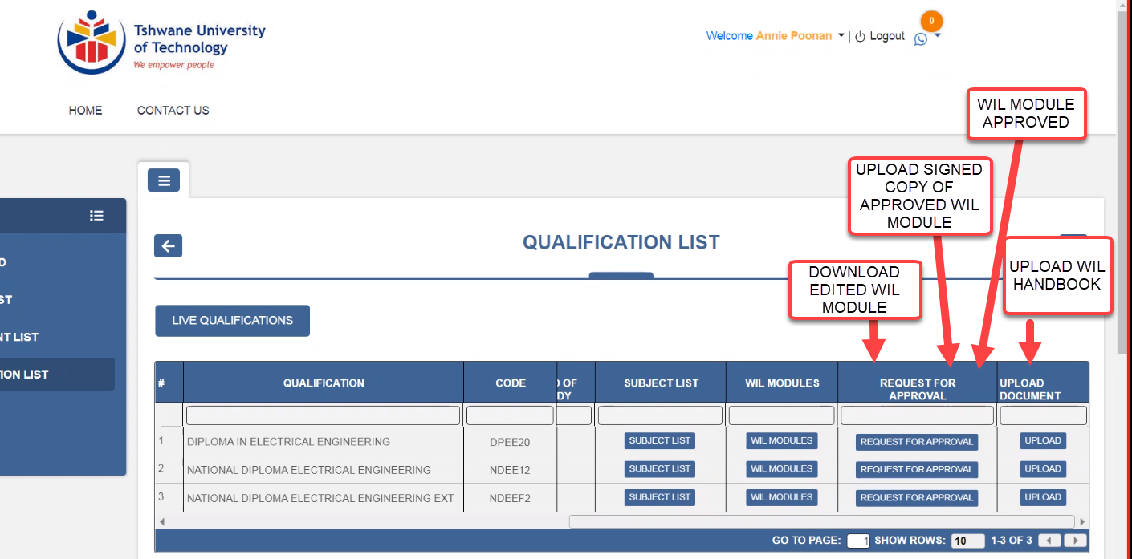

Vineet > Please check below latest pictures

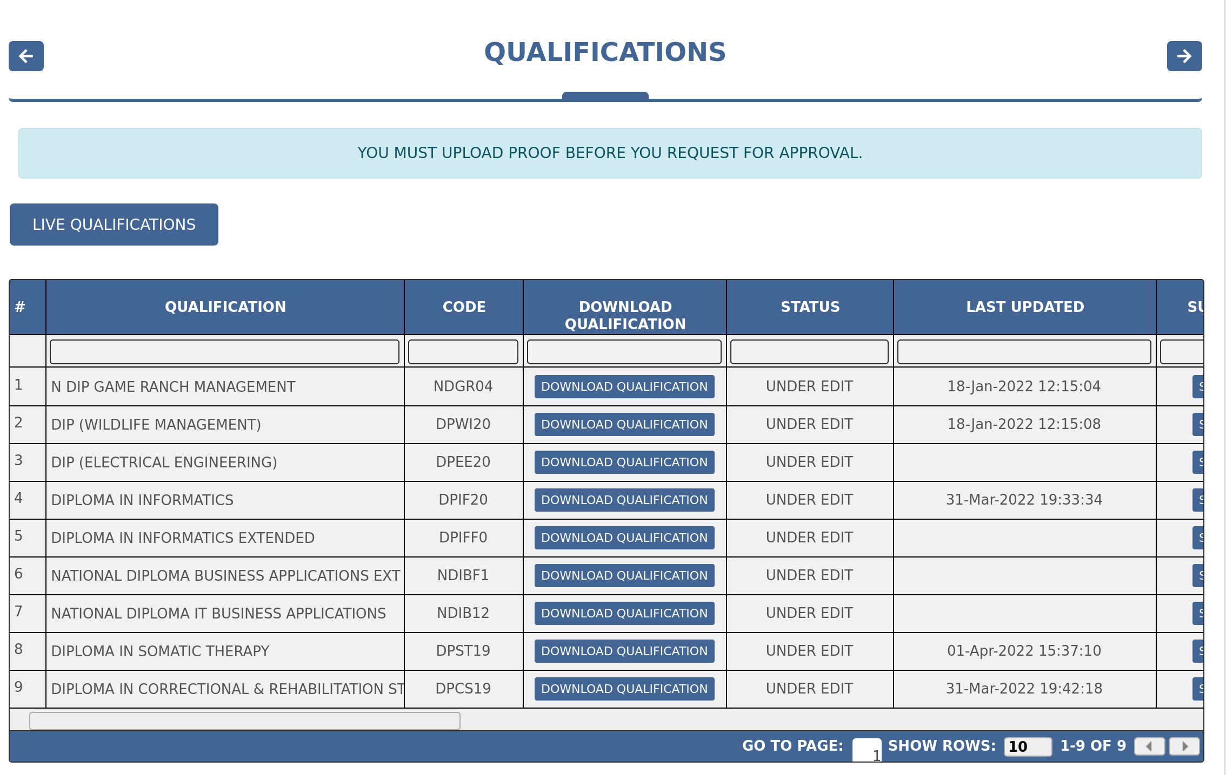

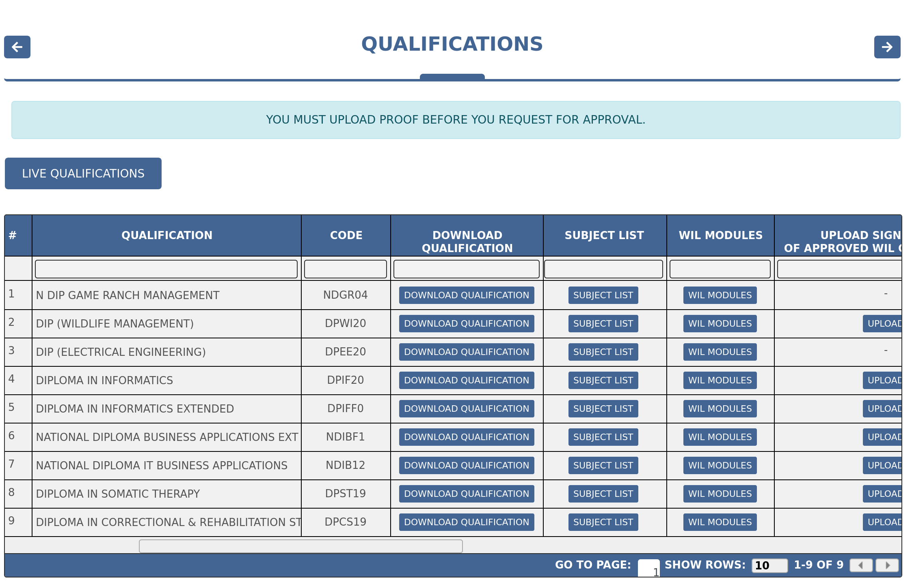

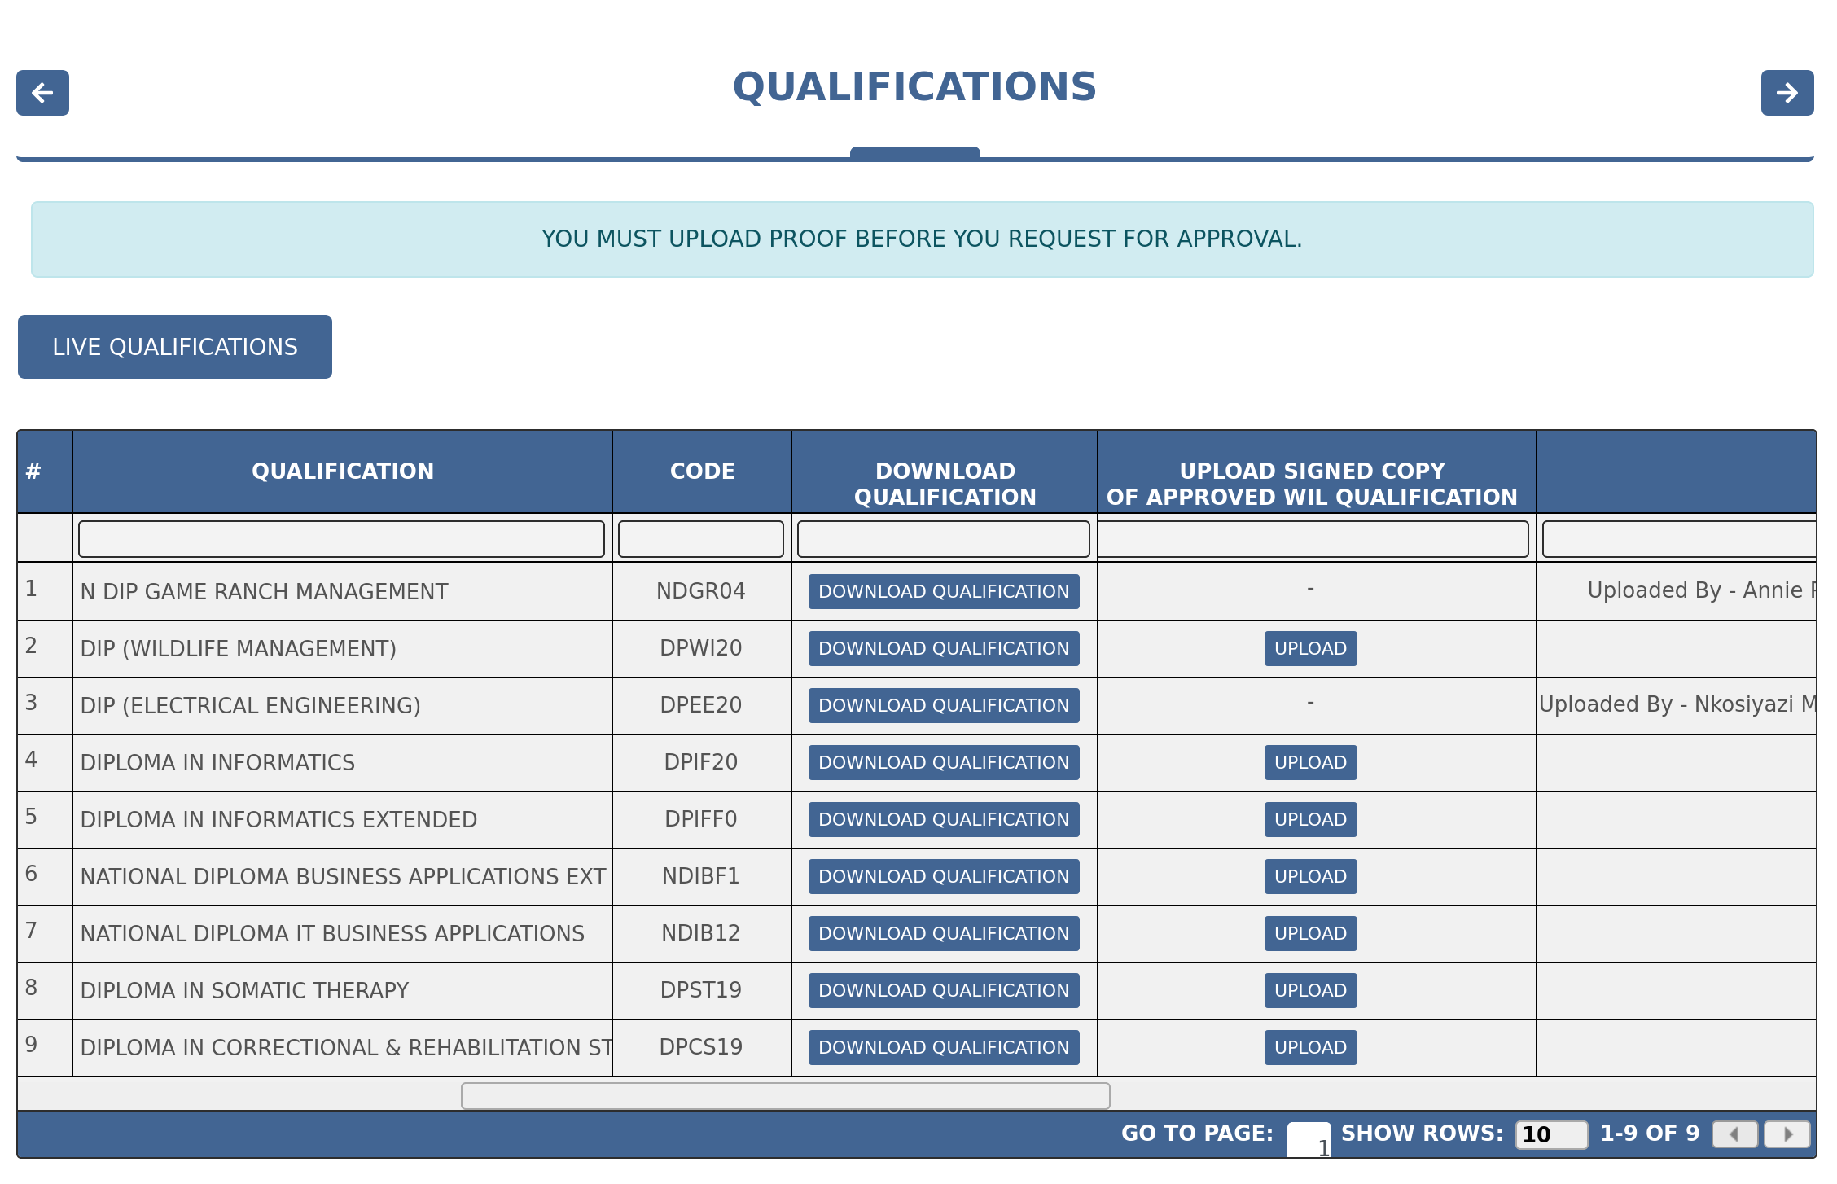

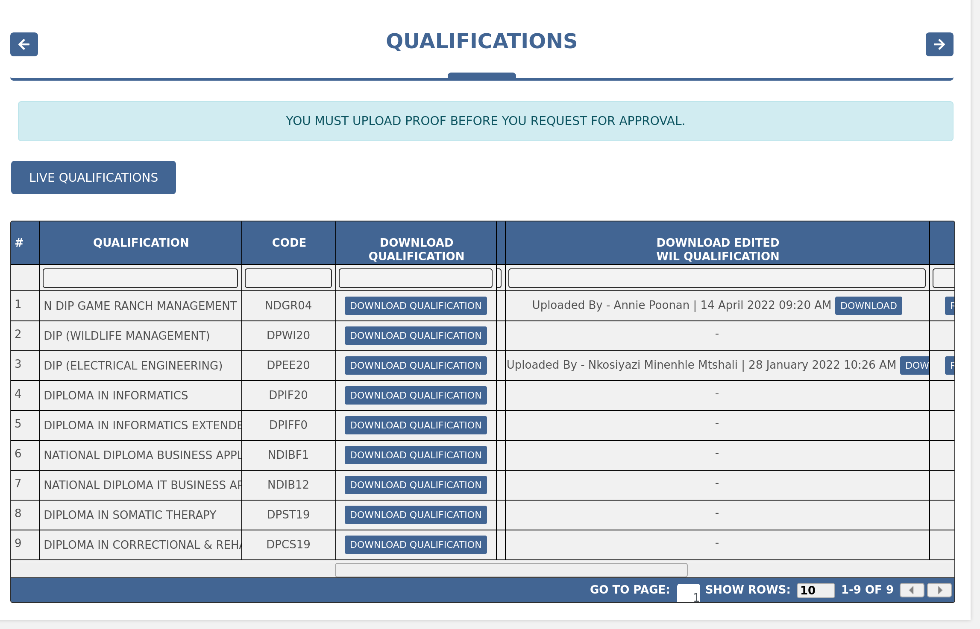

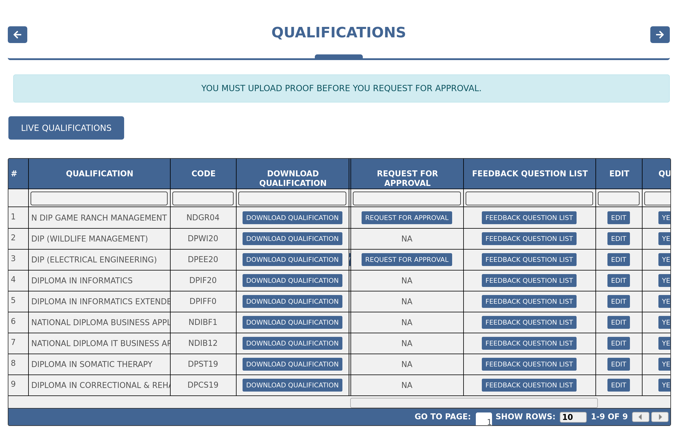

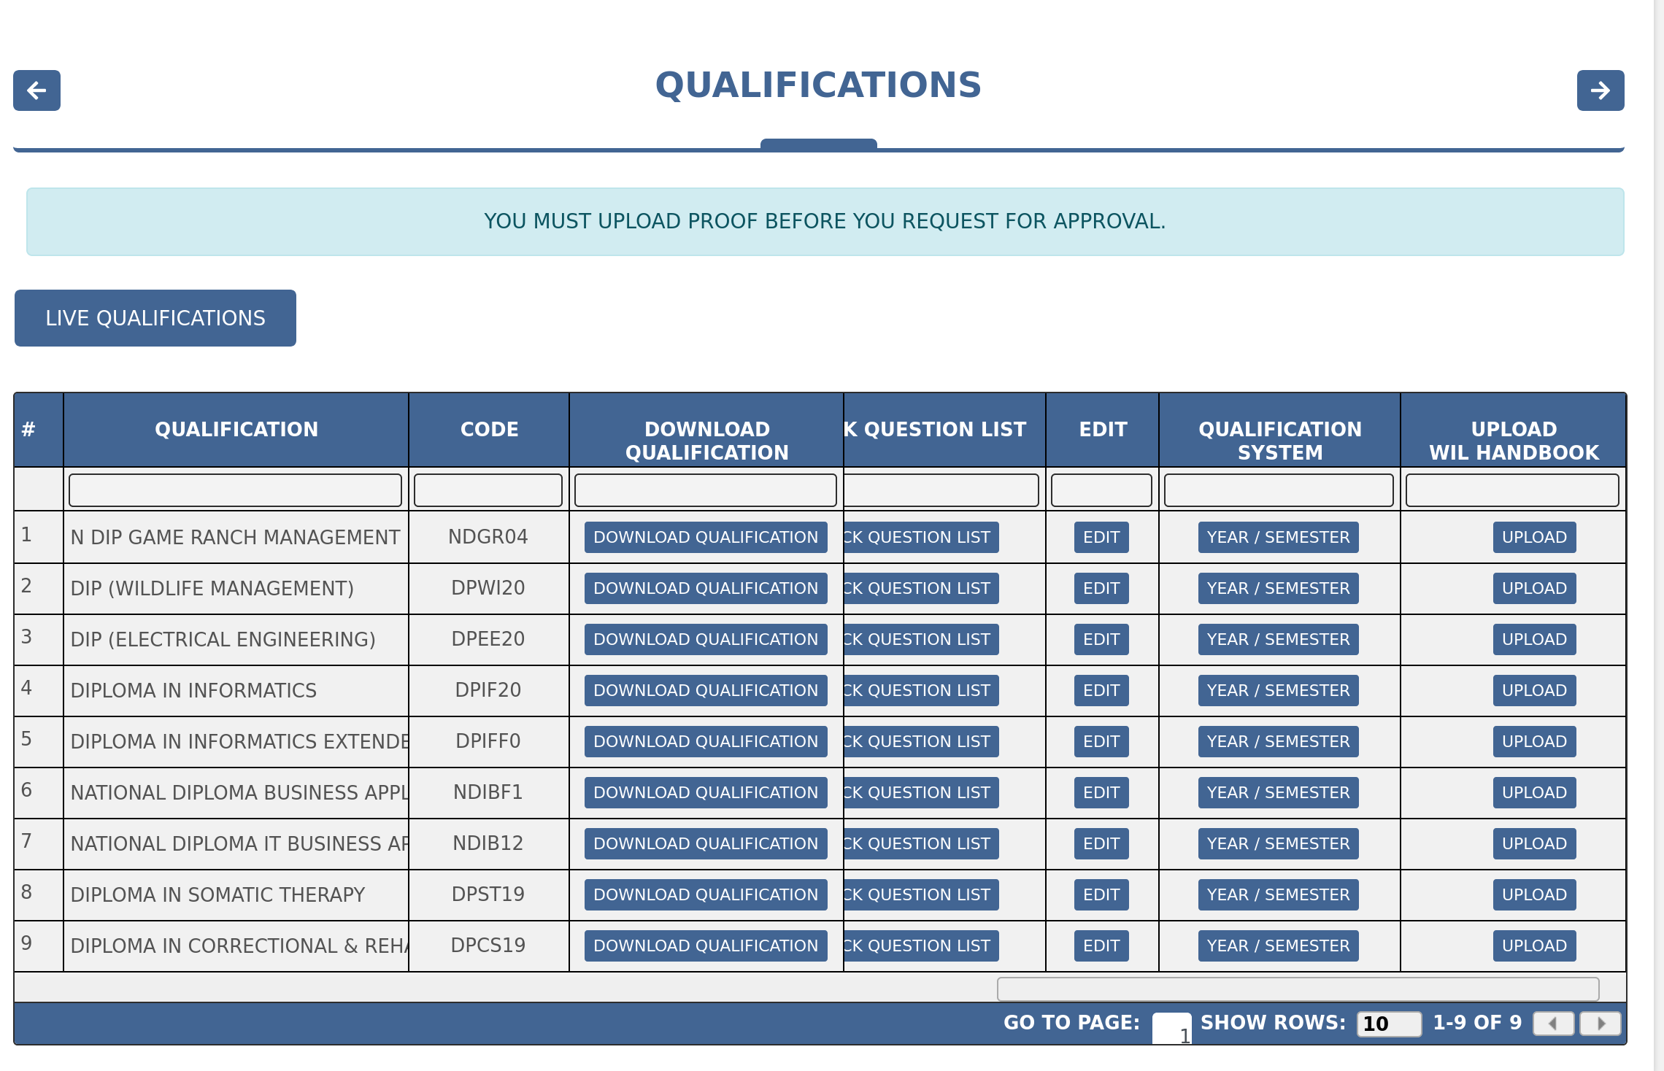

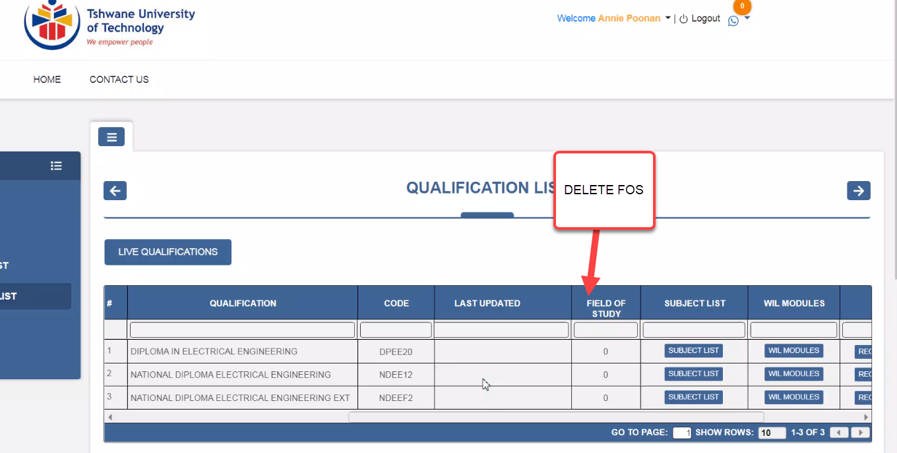  
  
Vineet > Will remove FOS

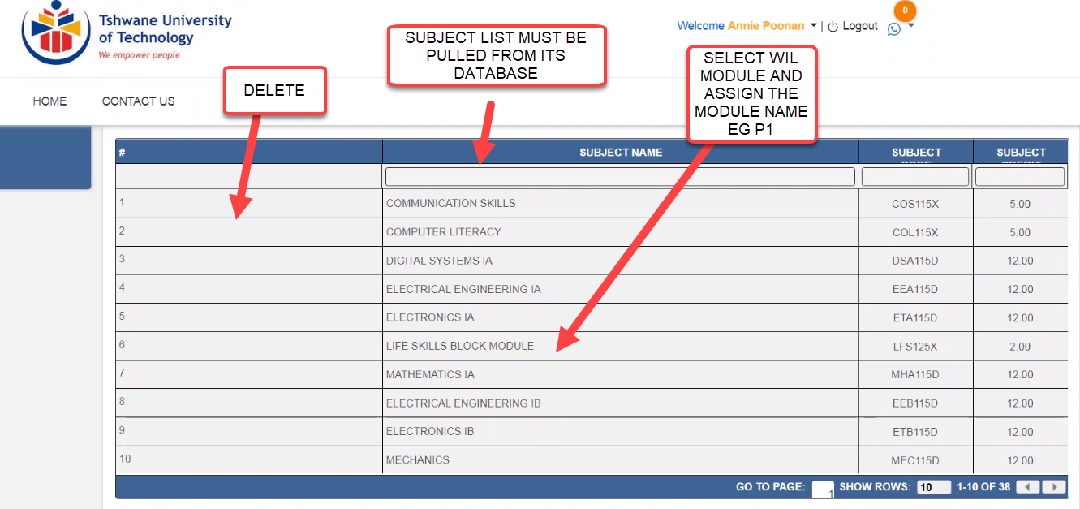

Vineet > In Qualification, there is flow to create WIL and at that time WIL Name and subject is assigned along with WIL Rules.

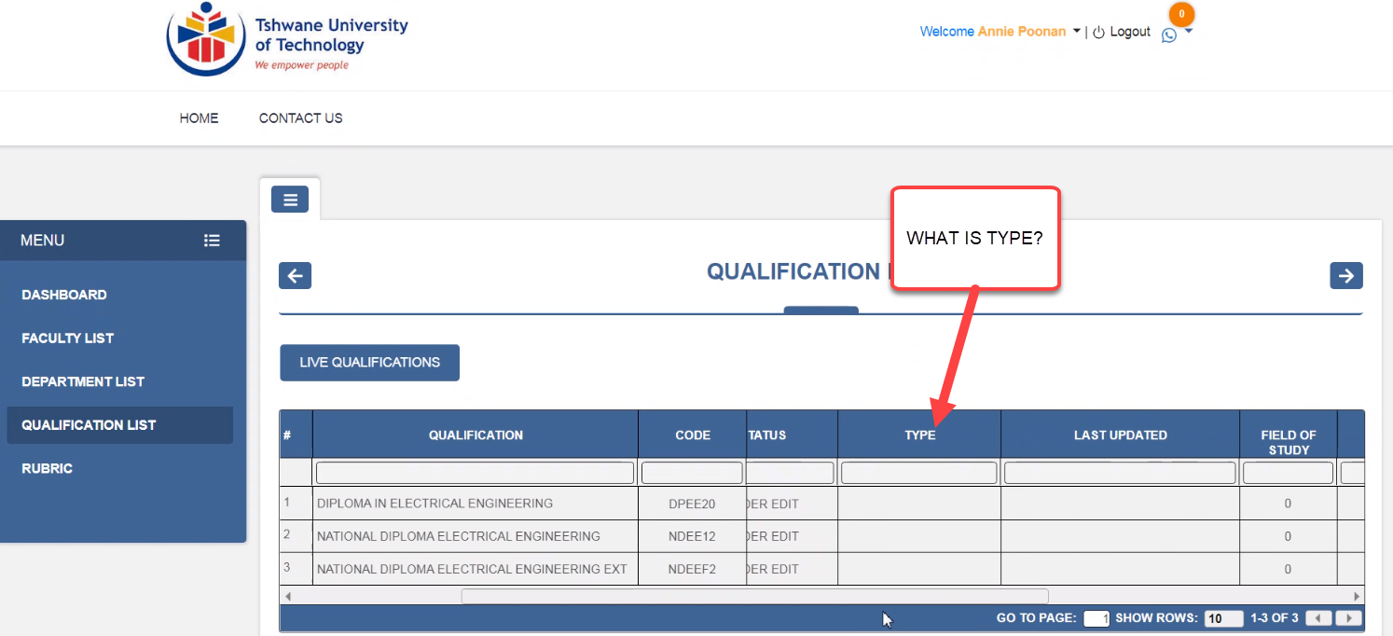

Vineet > will remove it, its was Nated / NCV

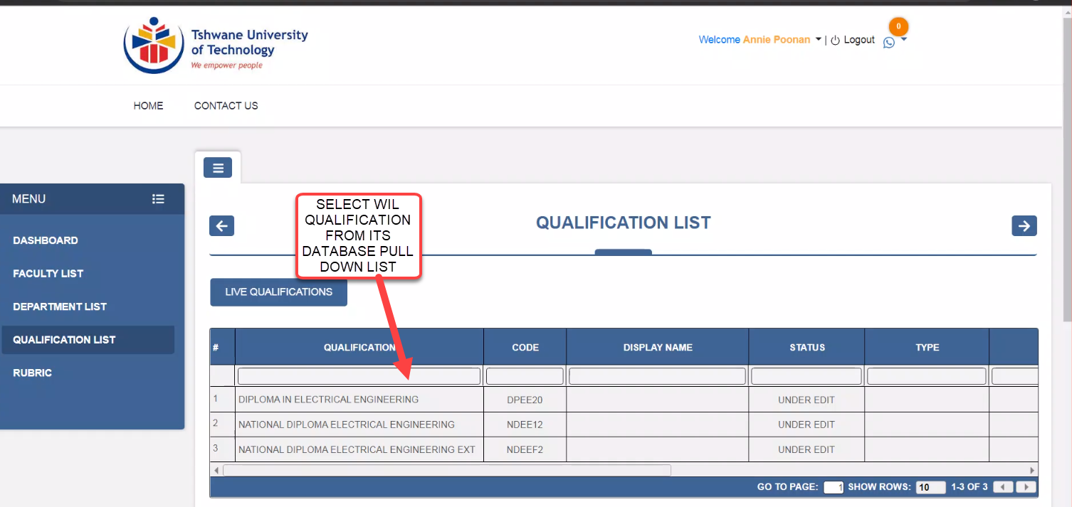

Vineet > All the Qualifications comes as Raw Qualification to superadmin, they superadmin will changes its status to under edit, then it will be visible to QSM to create WIL and put all rules and information then QSM request for Approval from WIL ADMIN With Signed Logbook Document. WIL will check document and make it LIVE. Only Qualification in one department will be live, To live same qualification for other department or campus it will require same process, We can create a function to copy all rules and data from One Qualification to other Qualification...

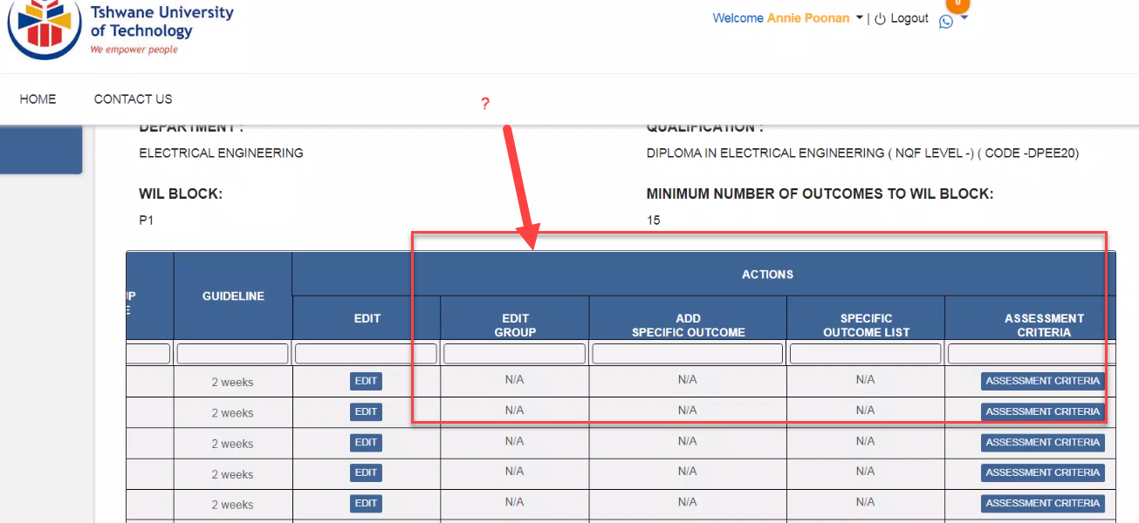

Vineet > Please see latest picture

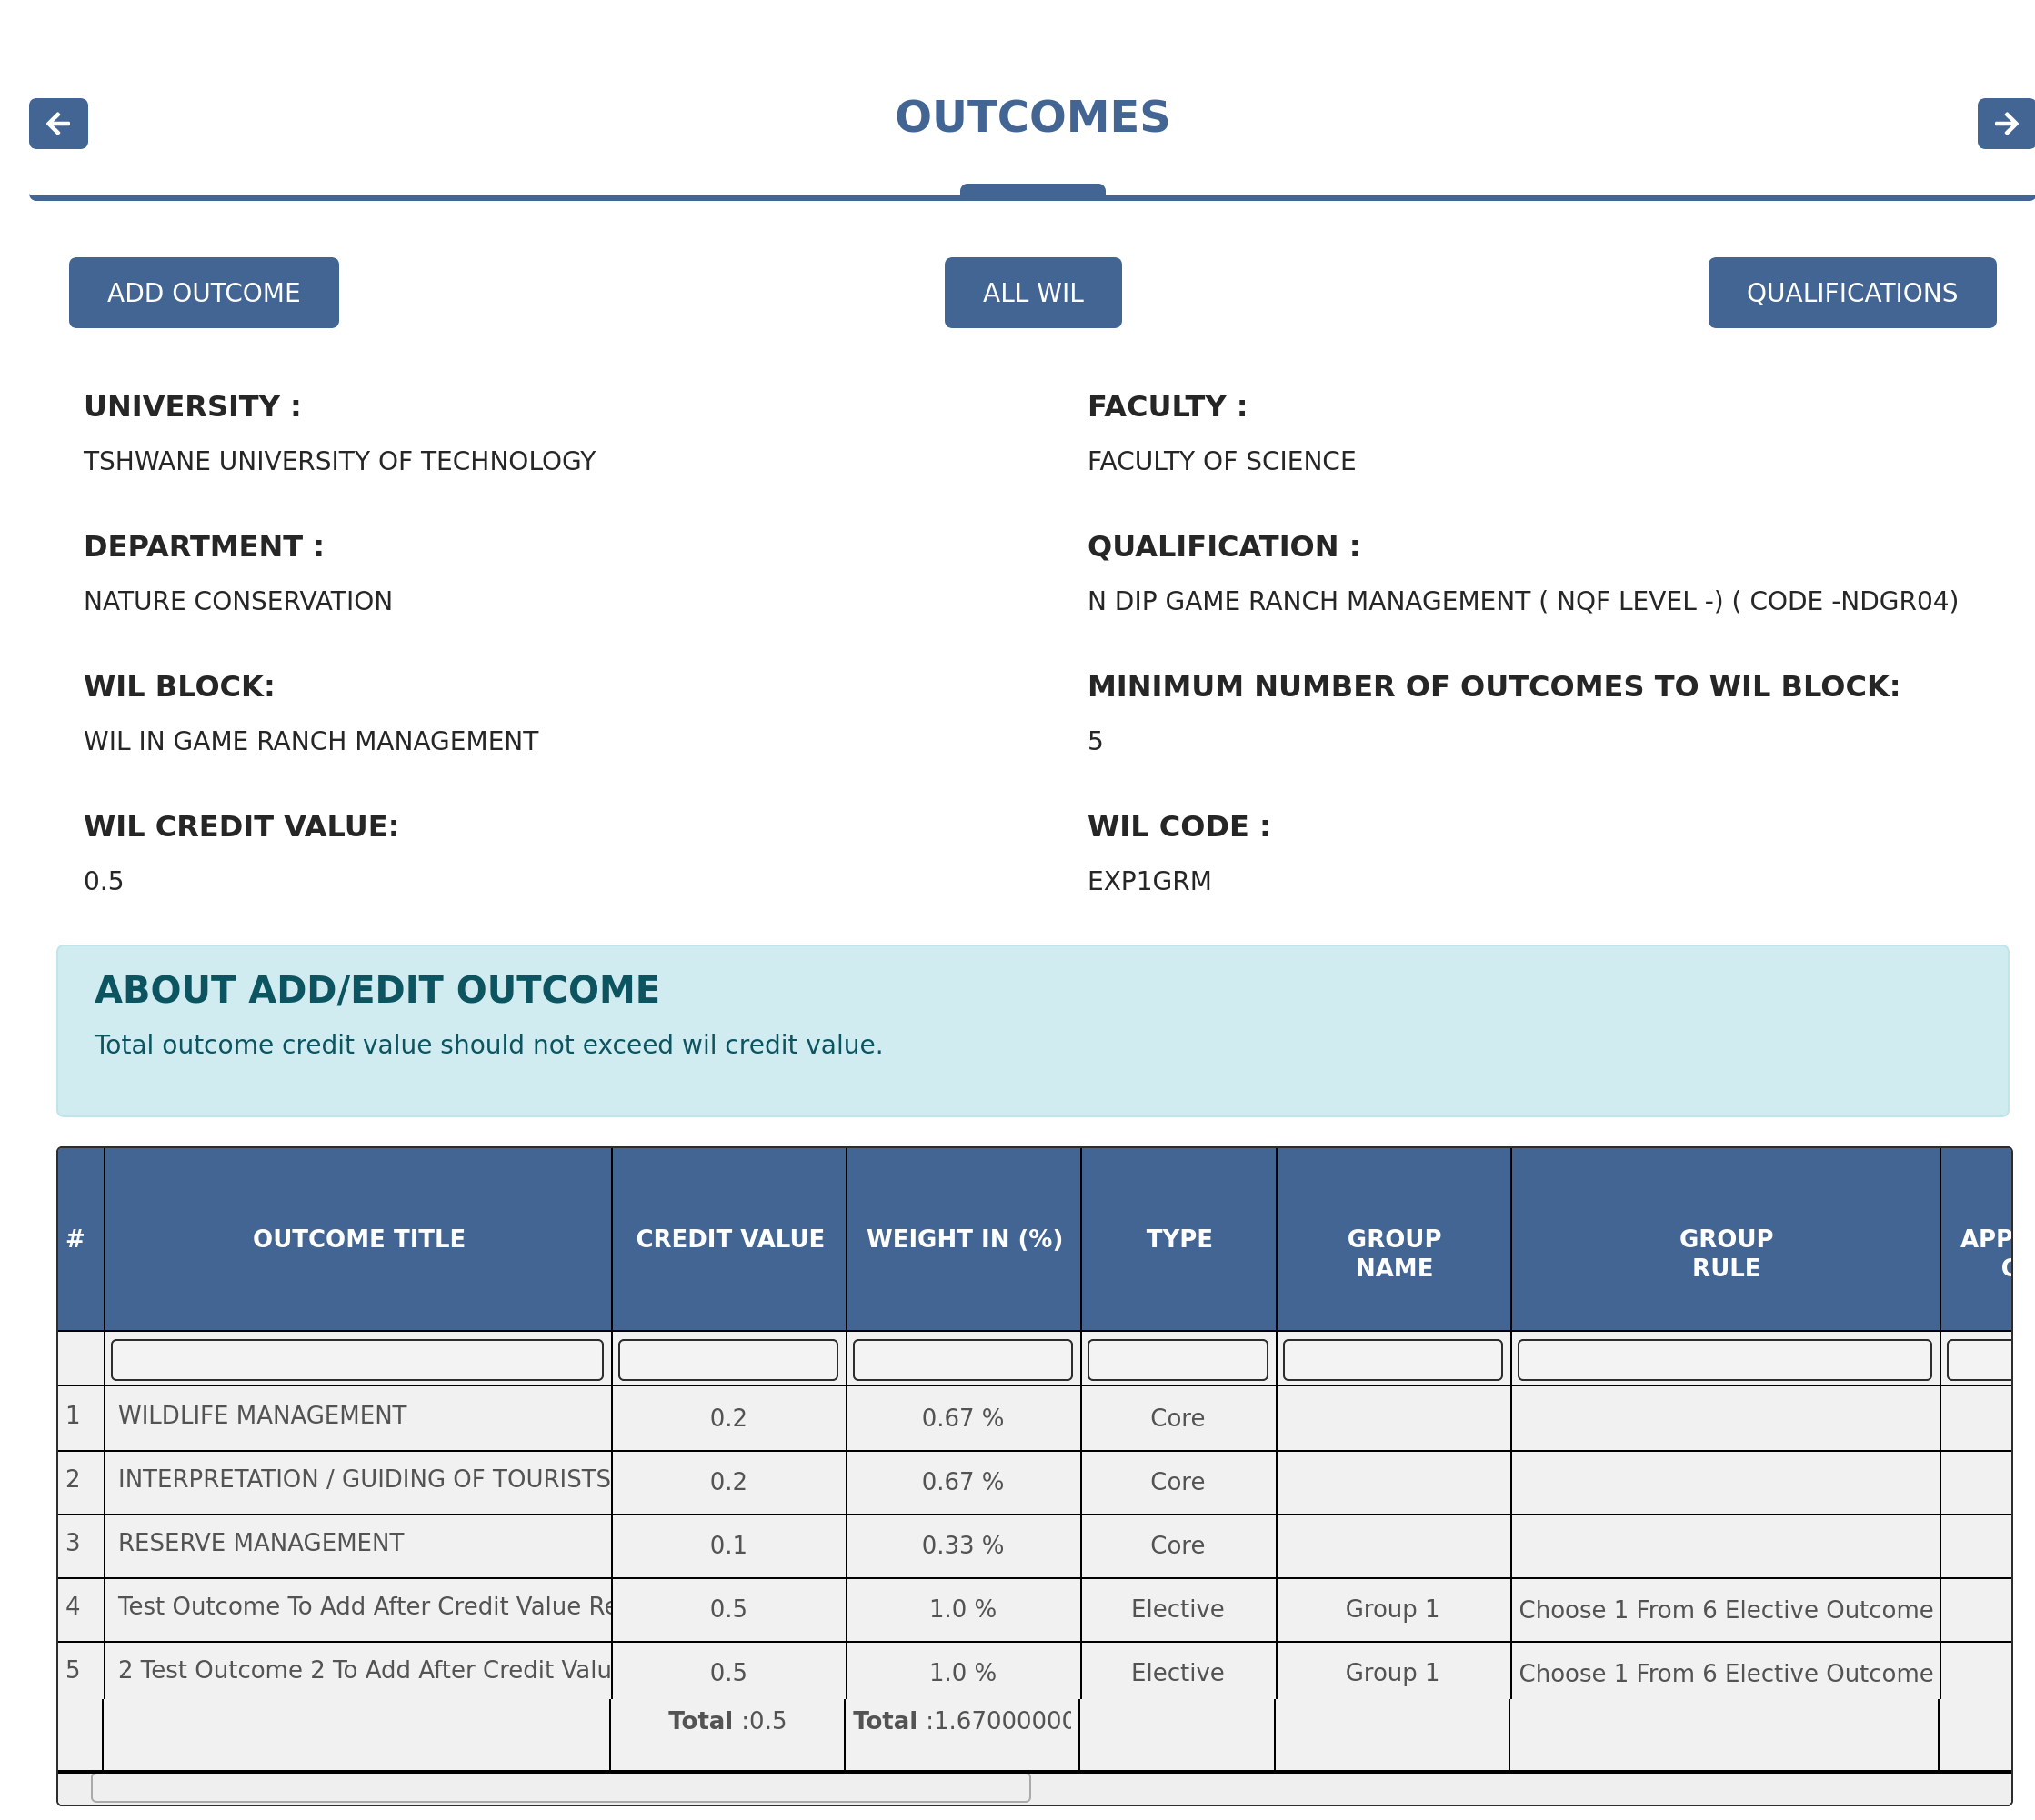

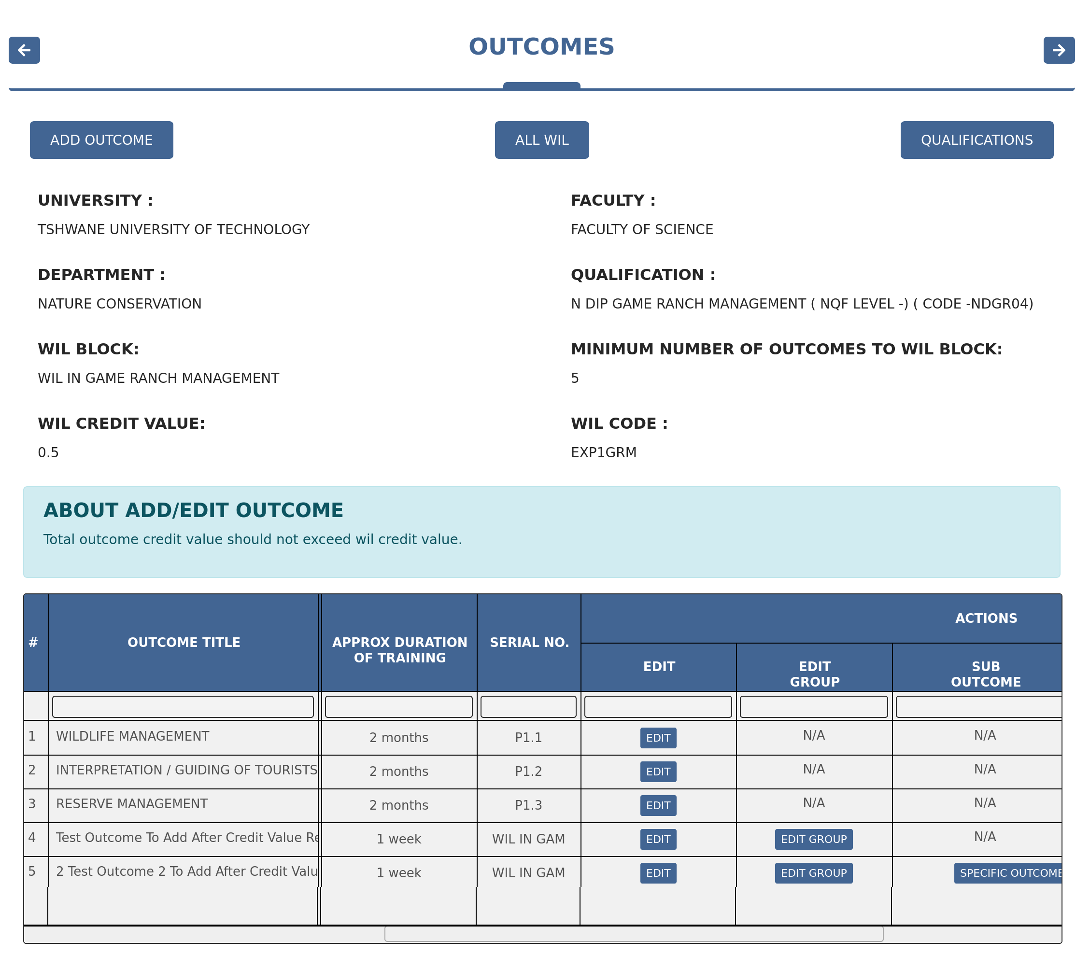

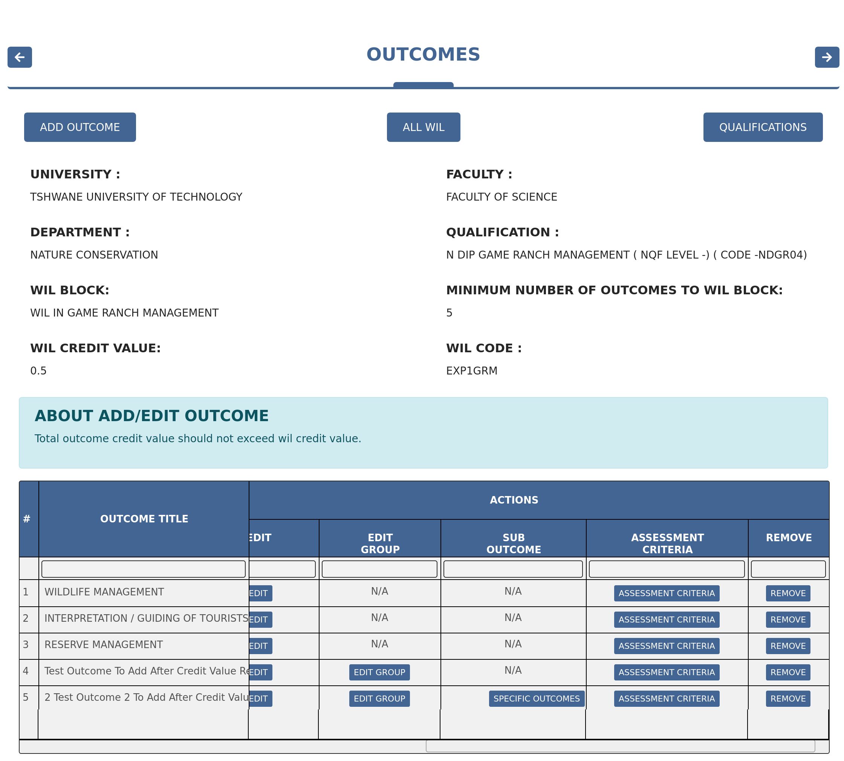

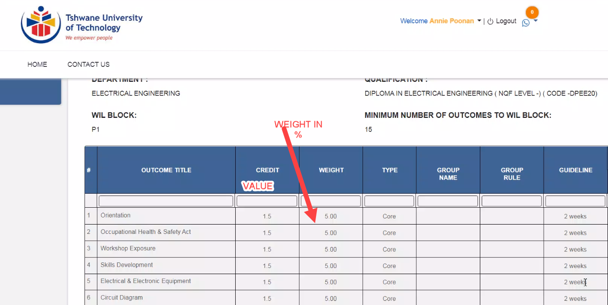

Vineet > Please see latest picture on top

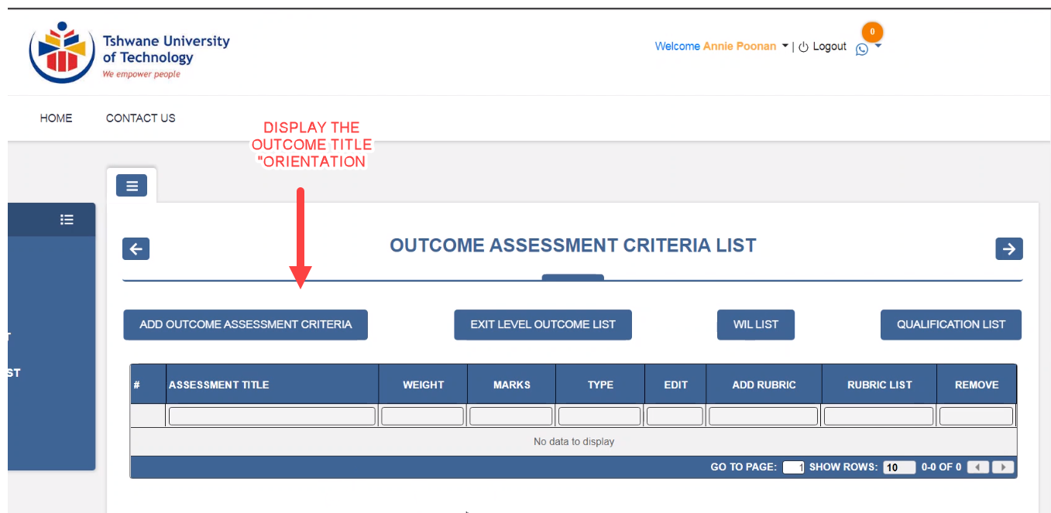

Vineet > This is the latest picture of this page

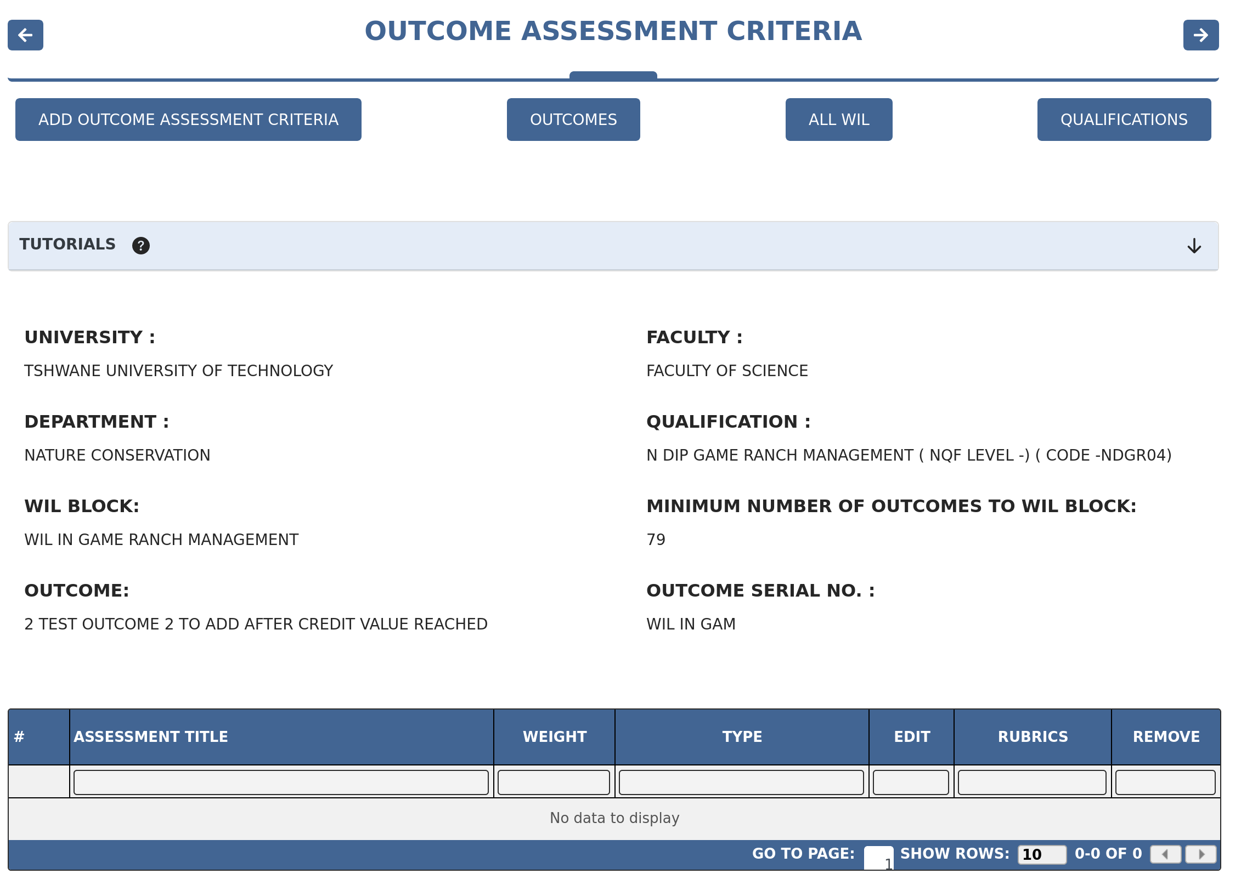

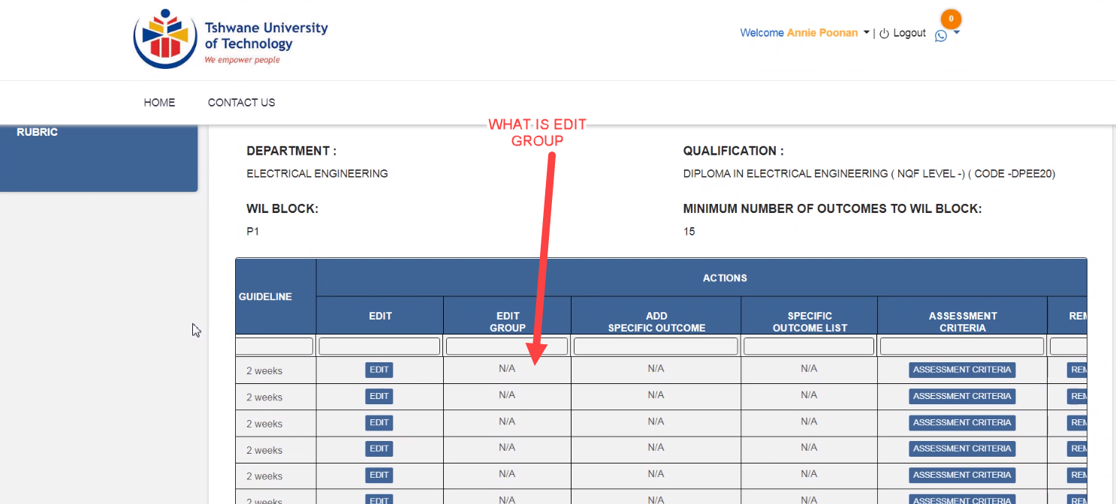

Vineet > A group is created for Elective outcomes, Group Name column will show name of the group and in Edit Group column, a button will come to edit the group info

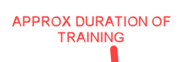

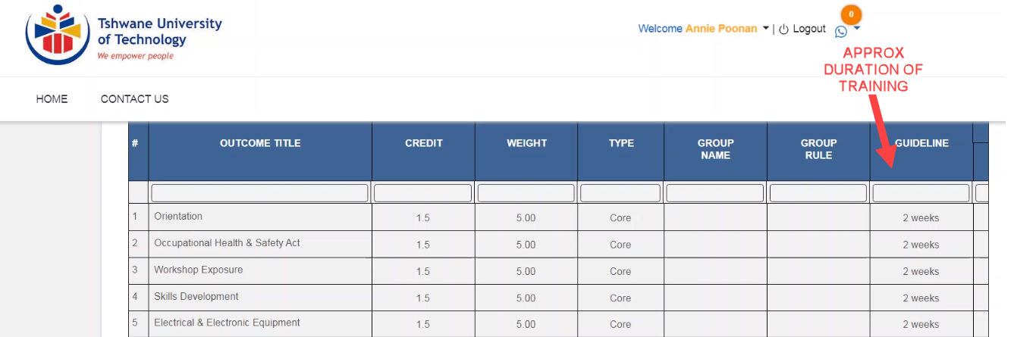

Vineet > Please see latest picture on top Named as outcome

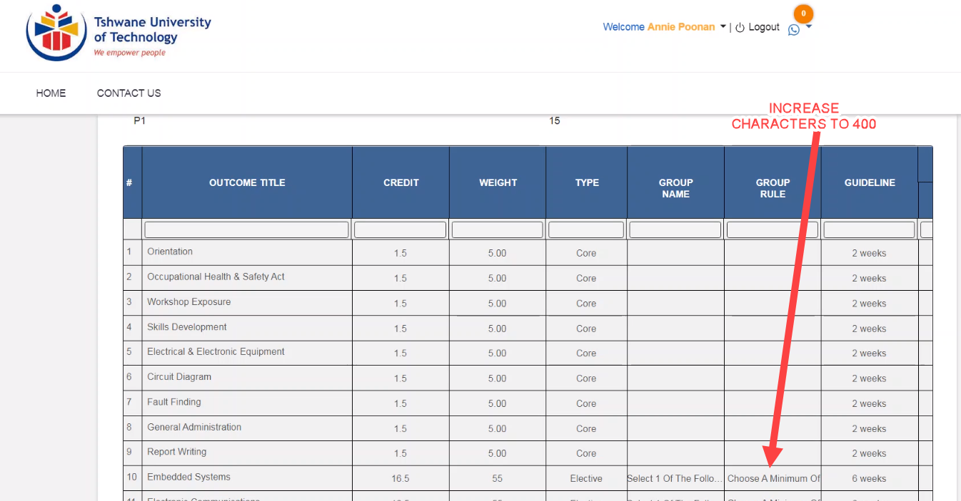

Vineet > Character is ok, On mouse over Group Rule, we are showing full text

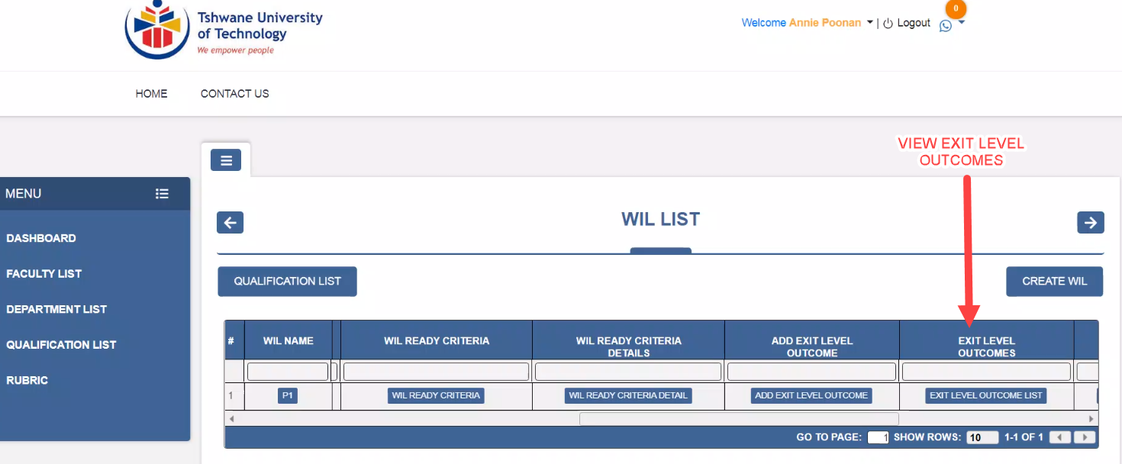

Vineet > This is the latest screen

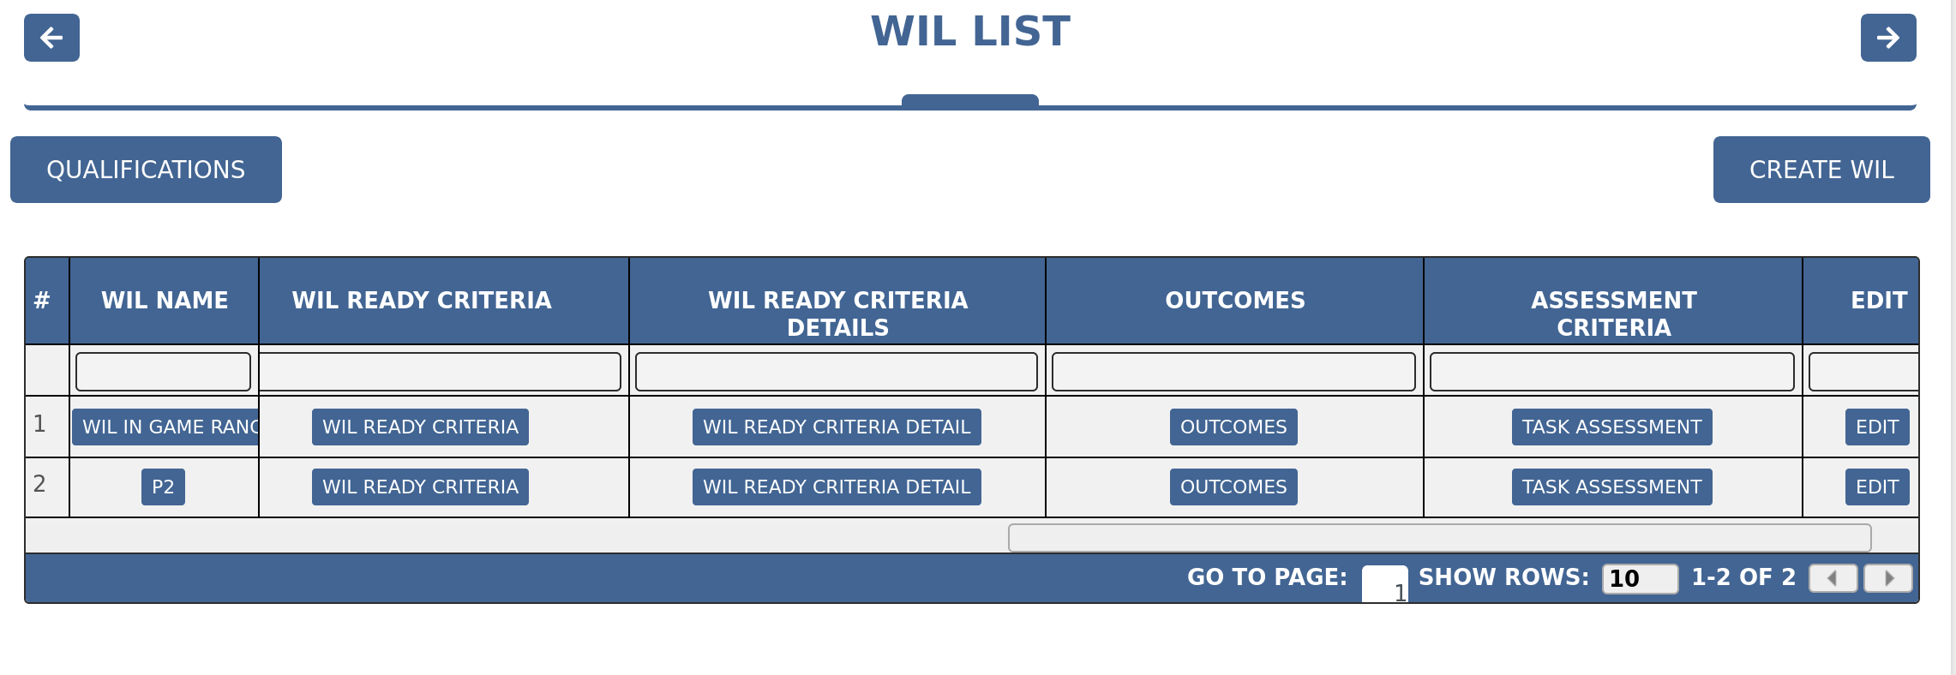

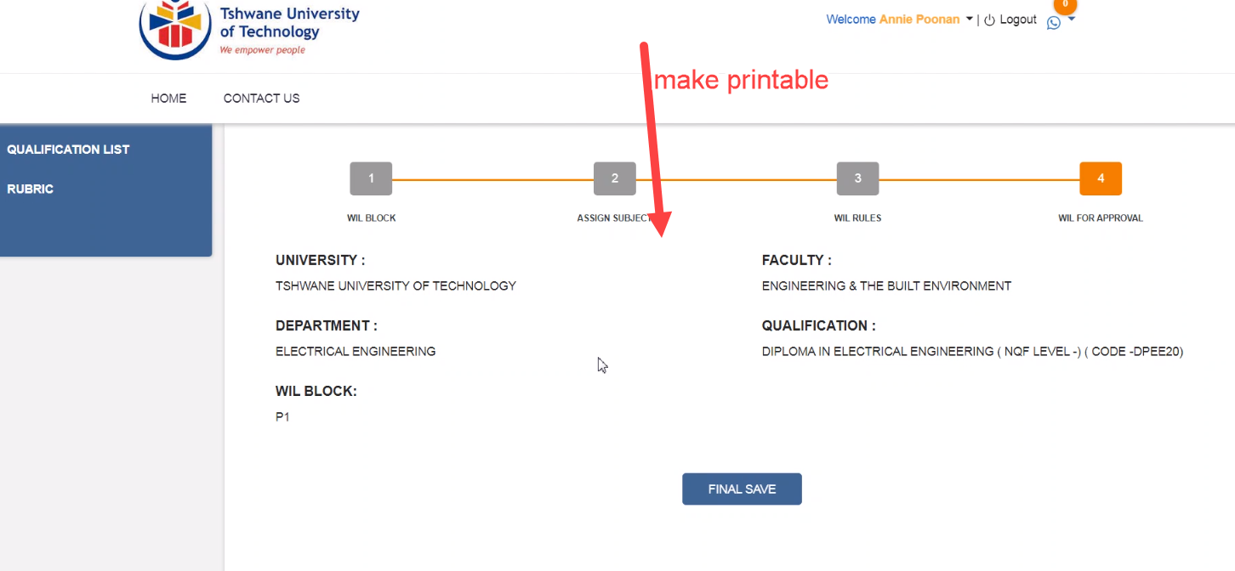

Vineet > We will show full details of WIL on this page, we already have logbook which shows all the information regarding WIL

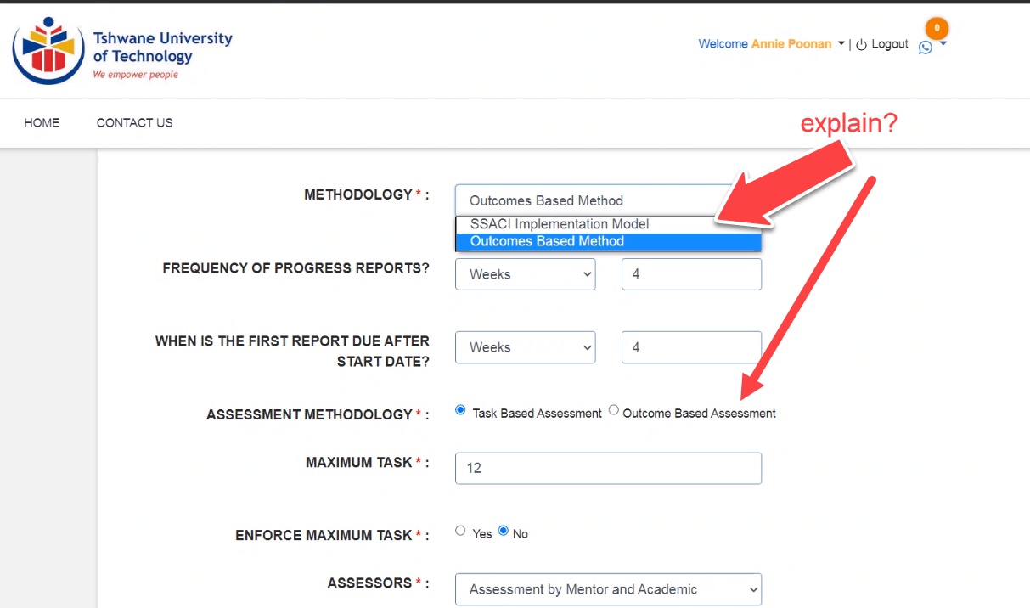

Vineet > we will remove WIL Methodology, it was previously created for ssaci model to have Fixed Question and Journal. Assessment Methodology is Assessment will be done on Task Based(formative) or Outcome (summative).